MCRA/WCRA 10th Annual Regional Education Conference
Hosted  by | 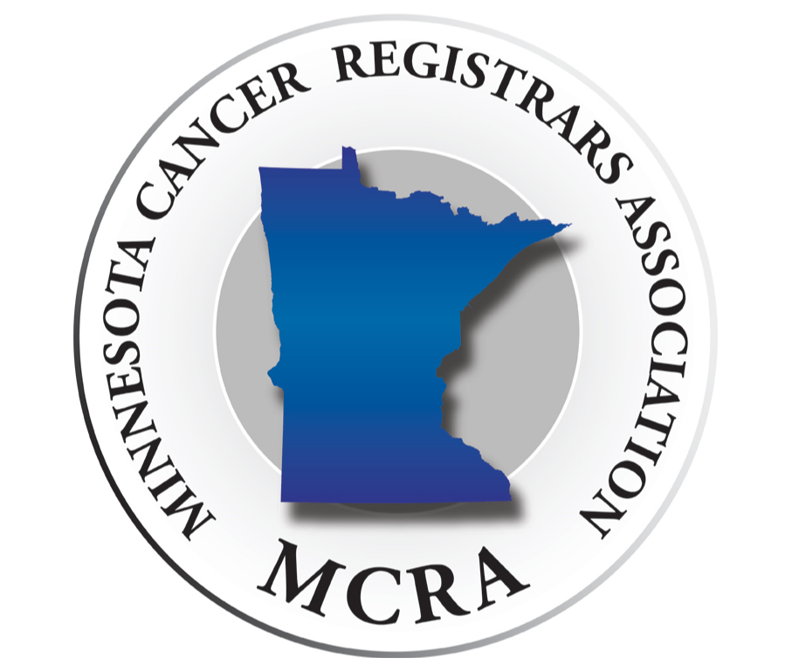 | & | 

October 9-10, 2025
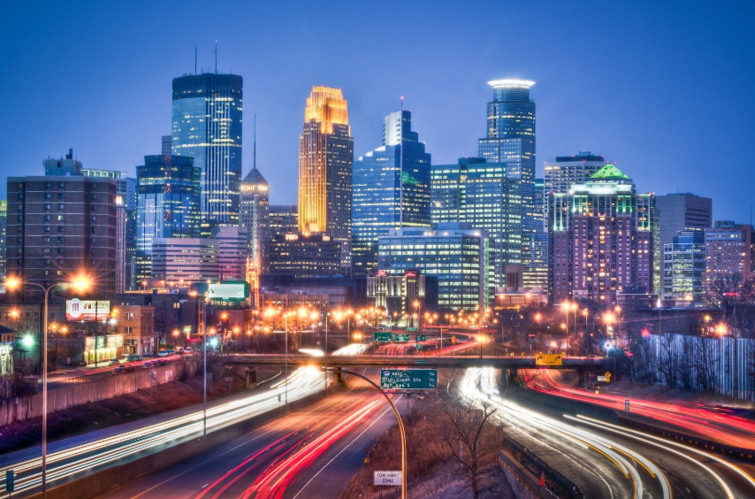 | Bloomington, MN | 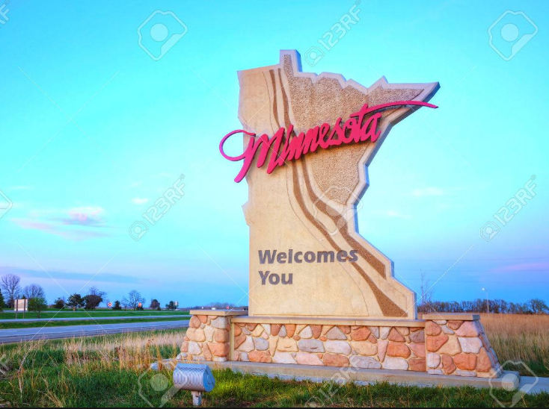

Embassy Suites Minneapolis Airport  7901 34th Ave S  Bloomington, MN  In-person and virtual registration will be available | 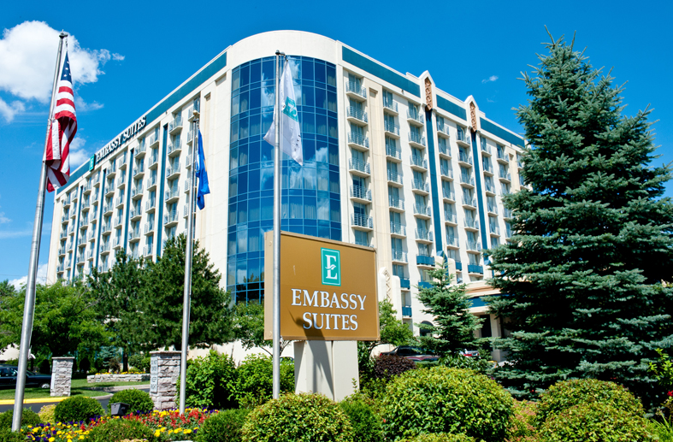

9.5 NCRA CE credits applied for

Thursday, October 9th
7:00 | Registration/Breakfast
7:50 AM | Welcome
8:00 AM – 9:00 AM | Lung: Multiple Tumors  Vicki Hawhee
9:00 AM – 10:00 AM | Thyroid  Vicki Hawhee
10:00 AM – 10:15 AM | Break
10:15 AM – 11:00 AM | Minnesota State Updates | Wisconsin State Updates
11:00 AM – 12:00 PM | MCRA Business Meeting | WCRA Business Meeting
12:00 PM – 1:30 PM | Lunch will be provided
1:30 PM – 2:30 PM | Cancer Registry Jeopardy  Vicki Hawhee
2:30 PM – 3:30 PM | Site Specific Data Items – Common Misunderstandings  Vicki Hawhee
3:30 PM – 3:45 PM | Break
3:45 PM – 4:30 PM | How Anatomy Can Help you Correctly Code SSDI’s  Breana Norton
4:30 PM | Social Hour  Appetizers provided  Woolley’s North Area

Friday, October 10th
7:00 AM | Breakfast
7:50 AM | Welcome
8:00 AM – 9:00 AM | Hematopoietic  Vicki Hawhee
9:00 AM – 10:00 AM | Breast  Vicki Hawhee
10:00 AM – 10:15 AM | Break
10:15 AM – 11:15 AM | Oncology Tests/AI  Dr. Gary Grammens
11:15 AM – 12:15 PM | Did You Know?  Sara Biese
12:15 PM | Closing Remarks

Conference Fees
Early Bird Rate (7/21/25 – 8/31/25)
 | Thursday & Friday
MCRA/WCRA Member | $80
Non-Member | $130
Student | $60

Regular Rate (9/1/25 – 9/26/25)
 | Thursday & Friday
MCRA/WCRA Member | $125
Non-Member | $175
Student | $75

*Students cannot be currently working in the registry field and must show proof of enrollment in a RHIT/RHIA or CTR program with their registration to be eligible for the student rate. Please provide a photocopy of your student ID with year or enrollment or an unofficial transcript on school letterhead.

*Cancellation Policy: Cancellations must be received in writing by 9/26/25 to be eligible for a refund. MCRA will accept cancellations by mail or e-mail and will provide a refund to those received on or before 9/26/25. For cancellations received during the specified time, the refund will be issued on the next business day after the last day of the conference. MCRA will refund the registration fees paid, less a $20 processing charge. No cancellations will be accepted for refund after 09/26/25. Attendee substitution is permitted.

Registration
To register for the 10th Annual MCRA/WCRA Regional Conference follow this link https://fs28.formsite.com/minnesotaMCRA/2025ConferenceReg/index and complete the online registration. There are options to pay by check or through PayPal with an account or as a guest with a credit or debit card.

If paying by check please print out your registration confirmation or include your registration reference number and mail it with a check made out to MCRA to:
Amanda Hlad
6429 200th Street
Randall MN 56475

Group checks are welcome, but we ask that individual attendees complete the online registration and then give their organization their printed registration confirmation to be mailed with the check.

Group invoices can also be done – please contact Amanda Hlad at the email address below to coordinate.

Please contact Amanda Hlad with any questions:
minnesotaMCRA@gmail.com

Lodging
Embassy Suites Minneapolis Airport
7901 34th Ave S
Bloomington, MN
952-854-1000
www.embassymspairport.com

Rates:
2 Queen Beds with Sleeper Sofa $174*/night
$15 nightly parking fee
*Plus tax. Includes Wi-Fi and breakfast both mornings.

In-person conference attendees will also have a light breakfast of fruit, pastries, and coffee available Thursday and Friday morning.

A block of rooms is being held until 09/17/2025 for Wednesday and Thursday nights. Reservation methods:
Online Group Page
Click on the link below which will bring you to your group’s personalized reservation page.
https://www.hilton.com/en/attend-my-event/mcrawcrafallconference2025/
Phone
Call 952-854-1000 or 1-800-Embassy, and let them know you need to make a reservation in the MCRA/WCRA Fall Conference block. Let them know the Group Code: CES934

The hotel offers a complimentary shuttle to and from the Mall of America and the Minneapolis Airport.

