MODmM spring/summer 2022

President’s Message

by Jackie Halsey, CNMT, CTR

What an honor to represent this association at the National Cancer Registrars Association (NCRA) conference in Washington DC. Minnesota Cancer Registrars Association (MCRA) allows the current president to attend as a benefit for volunteering. The saying “You will never miss a good thing until it is gone” really hit home to me about on-site conferences.

Do not get me wrong, I love remote working, yoga pants, zero commute and zoom meetings plus I love my cat on my lap and the flexible family life. However, the main reason we need on-site conferences is because of the internal feeling and meaning it delivers.

**“Connection is why we are here. We are hardwired to connect with others, it is what gives meaning to ourselves and without it there is suffering.” Brene’ Brown**

At NCRA, I connected with the standard setters’ and presenters whose voices I recognize from their webinars. I saw old co-workers plus met new CTRs and other cancer registry instructors. We were able to share our knowledge and talk in our CTR language. At the president luncheon, it was a joy to swap stories and suggest ideas with other state association presidents.

Even though an on-site conference has wonderful comradery, I hope hybrid is the future for conferences as education is essential and should be available to all. This fall, Wisconsin Cancer Registrars Association will be planning the Regional WCRA/MCRA Conference and confirmed virtual will be an option. Details will come later.

However, if able, expense and healthwise plus willing to travel, take time to think pre-COVID era to the last on-site conference you attended and ponder the thought, “Have you ever left a conference regretting you went there, or have you left with the inside comradery feeling?

Save the Date! July 19, 20, 21

The 2022 SEER Advanced Topics for Registry Professionals will be held virtually on **July 19, 20, and 21**. This workshop will be free (registration will be required) and open to all cancer registrars. More information will be provided later. Check the Announcements on the Registry Operations page on the SEER website for updates, [https://seer.cancer.gov/registrars/](https://urldefense.com/v3/__https:/nam02.safelinks.protection.outlook.com/?url=https*3A*2F*2Fseer.cancer.gov*2Fregistrars*2F&data=04*7C01*7Cjackie.halsey*40rctc.edu*7Cf80d0827c850465d73c408d9fe23533c*7C5011c7c60ab446ab9ef4fae74a921a7f*7C0*7C0*7C637820249948233831*7CUnknown*7CTWFpbGZsb3d8eyJWIjoiMC4wLjAwMDAiLCJQIjoiV2luMzIiLCJBTiI6Ik1haWwiLCJXVCI6Mn0*3D*7C3000&sdata=p3wxPqgVEUk*2BSfCNyE*2F9y4pp6ZLZYtS0T8LsvOWtKck*3D&reserved=0__;JSUlJSUlJSUlJSUlJSUlJSUlJSU!!AQDxp81HYA!OSpG_k3FFKfwGNvll9G1XEF7rBVZ5lDH2GxvF6-oHgR4_NLRjlVh8-wAtksdwPkMg9tQD8Ly8nYBjPH-C0UULR47O4hy3A$)



NCRA 2022 Annual Educational Conference Recap

* Cancer Reporting is the most complex public health reporting in the US
* Per AJCC, Version 9, Anus and Appendix will be published in 2023
* For Version 9, can do print on demand through Amazon, then 3 to 5 days later, the print is mailed to you
* Low-grade appendiceal mucinous neoplasm LAMN (without mets) becomes reportable 1/1/2023 as 8480/2
* Starting of 2023 diagnosis, No SSDI ER and PR Allred Score. Leave field blank. Decisions made by feedback from AJCC physicians
* Once changes are documented in CAnswer Forum, they can be used
* Some registrars choose to follow updated guidelines from CAnswer Forum, others wait until the revised manual

published. Whichever path you choose is acceptable

* SSDI Melanoma Ulceration and Colon MSI: Can code 9 if an in-situ lesion. If information is not readily available, do not spend time looking for it, and code 9. Instructions updated
* LDH for Melanoma must be taken before any treatment and is usually ordered when distant mets are found or suspected. Common SSDI not to be there
* Code KI-67 from invasive component even if unknown
* Added to Grade Manual. Priority order for grade

a. Synoptic report (including CAP protocol)

b. Pathology report: Final diagnosis

c. Physician statement

* EOD does not derive AJCC since we don’t have T, N, M, and Stage Group for the different patient time frames Although AJCC and EOD have many similar rules, rules for the two are not identical
* Prostate Case Example) Clinical T: Blank (Per AJCC, a DRE is required to assign a Clinical T and we have no info on DRE) Summary Stage 1: Localized. The absence of DRE does not affect Summary Stage
* Per NAACCR, it takes a full 18 months to get a new data item for abstraction
* The future is Precision medicine. Wondering... What is Precision Medicine? Watch 2-minute Video [HERE](https://www.youtube.com/watch?v=zhS9WZiU46s)
* CancerPath Chart will be a future web tool for registrars that is freely available on SEER website. Hoping to implement January 2024. STR rules will be linked to it
* For liver, TACE is not a neoadjuvant treatment and coded as chemotherapy
* For melanoma, LDH is usually ordered when distant mets are found or suspected. Common SSDI not to be there
* Tattooing is affecting finding melanoma early
* More specific B cell lymphomas were added to the HEM Database
* New ICD 10 Case finding list for 2022

MCRS Update/Info

By Jennifer L. Nelson, CTR, NR-EMT

Minnesota Department of Health

**MINNESOTA CANCER REPORTING SYSTEM – MODMM ARTICLE SPRING/SUMMER 2022:**

* Gail Jolitz retired with her last day being March 23, 2022
* Changes to submissions:
  + Will change MDH File Transfer to Cloud Drive
    - MDH File Transfer will end 4/30/2022
    - Cloud Drive will be setup prior to the ending of MDH File Transfer but date is to be determined
    - Working on setting up users in Cloud Drive, writing instructions for how to submit to MCRS via Cloud Drive and messaging to all current MDH File Transfer users
* MCRS currently working on 2020 cases and 2020 Death Certificates
* CoC is not requiring COVID data items for 2022, however, just a reminder that the State of Minnesota is still requiring those COVID 19 data items, and they are listed on the MCRS website under Public Notice of Reportable Data Items to MCRS for 2022
  + R* (required if available) 3946 NCDB--COVID19--Tx Impact Dx 2020 & later
  + R* (required if available) 3944 NCDB--SARSCoV2--Pos Dx 2020 & later
  + R* (required if available) 3945 NCDB--SARSCoV2--Pos Date Dx 2020 & later
  + R* (required if available) 3943 NCDB--SARSCoV2--Test Dx 2020 & later
* Minnesota’s FLccSC site
  + Free courses
    - CEUs not always offered but contain good educational information
    - <https://mns.fcdslms.med.miami.edu/ords/f?p=105:LOGIN_DESKTOP>
* NAACCR Data Item Relationships 2022 Webinar
  + Jennifer Ruhl stated small cell carcinoma default grade is 4 (always a grade 4 for lung.  Always the highest grade in the grading system for whatever specific primary site you are working on – i.e., bladder is 3, prostate would be 5, etc.).
    - Stated this information is in the CAnswer Forum **only** right now, but it will be added to the manual in the future.
    - SEER received confirmation regarding using high grade in 2021 but it can apply it to cases 2018+, however, she stated you do not have to go back and fix cases.
* NCRA Annual Conference
  + Presentation by Peggy Adamo - What Registrars Need to Know for 2022 from SEER
    - Equivalent to **“Diagnostic for”** malignancy or reportable diagnosis. These phrases are reportable when no other information is available.
      * Considered to be [malignancy or reportable diagnosis]
      * Characteristic of [malignancy or reportable diagnosis]
      * Appears to be a [malignancy or reportable diagnosis]
      * Most compatible with [malignancy or reportable diagnosis]
      * Most certainly [malignancy or reportable diagnosis]
      * In keeping with
    - Equivalent to **“Not diagnostic for”** malignancy or reportable diagnosis. These phrases are NOT reportable when no other information is available.
      * Highly suspicious for, but not diagnostic of [malignancy or reportable diagnosis]
      * Most compatible with a [non-reportable diagnosis] such as a [reportable diagnosis]
      * High probability for [malignancy or reportable diagnosis]
    - These terms have been added to the SEER Program Coding and Staging Manual 2022
      * Peggy stated reportability changes were agreed upon by all Standard Setters so these items will be added to the STORE Manual

Nominating Committee Message

Erin Hammell, RHIT, CTR; Nancy Hedstrom, RHIT, CTR; Jess Klaphake, RHIT, CTR; Candace Scherping, RHIT, CTR

The nominating committee is looking for volunteers and/or nominations for executive board positions for 2022/2023. *Please strongly consider volunteering so that we may keep our organization running smoothly.*

**Eligibility:** Any member in good standing for one full year prior to nomination shall be eligible to hold office. To be eligible for the office of President-Elect, a member must have served one full term on the Executive Committee prior to nomination.

**These are the positions open for 2022/2023:**

**President-Elect:** Shall assume the duties of the President in his/her absence and shall succeed to the office of President at the conclusion of his/her term of office. The President-Elect shall co-chair the Professional Development committee. Ensure website information is correct.

**Secretary:** Shall be responsible for records of all MCRA proceedings and shall distribute minutes of all business meetings to the membership.

**Treasurer:** Shall be responsible for the receipt and disbursement of all funds of MCRA and shall make written reports to the Executive Committee and to the membership. The treasurer shall serve on the Membership Committee.

**These are the committees needing volunteers for 2022/2023:**

**Professional Development Committee:** Shall be Responsible for leadership in the Professional Development of MCRA membership. It shall include the President-Elect, with responsibility for educational programs. It will include persons responsible for support of members seeking CTR status, and any other members as deemed by the President or the Executive Committee.

**Communications Committee:** The Communications Committee will include persons responsiblefor the MCRA newsletter, the MODMM (The Minnesota Oncology Data Managers Monitor) and for taking photographs. Liaisons to the Minnesota Cancer Council, National Cancer Registrars association, Minnesota Health Information Management Association, Commission on Cancer, Minnesota Cancer Surveillance System, Others as felt necessary, in order to carry on the responsibilities of the communications committee.

**Nominating Committee:** There shall be at least four members on the Nominating Committee, the chairperson (appointed by the newly elected President), the immediate Past-President, and two other members elected by the MCRA at the Fall Annual Meeting. They are responsible for preparing, mailing, and tallying the ballots in accord with Article V. No member of this committee shall be eligible for office.

**Membership Committee:** Shall be responsible for acceptance of new members and for distribution of updated rosters to the members. The MCRA Treasurer shall be a member of this committee and provide updated information on payment of dues.

If you are interested in volunteering and/or nominating anyone for any of these positions, please contact one of the above nominating committee members.

Thank you for your consideration in fulfilling these positions.



Did you know?

The NCRA has a great resource to share with others who may be interested in becoming a CTR.

<https://www.ncra-usa.org/About/Become-a-Cancer-Registrar>

Share the love!

Professional Development News

Jennifer Monsebroten, CTR; Heidi Leach, RHIT, CTR; Melanie Johnson, RHIA, CTR

Professional Development would like to remind members of the opportunity to receive assistance if you plan on sitting for the CTR Exam. MCRA Members in good standing, who have not previously sat for the exam, can apply for a one-time $100 stipend to be applied to your sitting fee. Contact Amanda Hlad, [Amanda.hlad@EssentiaHealth.org](mailto:Amanda.hlad@EssentiaHealth.org), to find out more.

As a member benefit to all, MCRA subscribes to the monthly webinar series published by NAACCR. Communications Director, Breana Norton, sends notice of the live recording each month, however these are also available to watch after and receive CEs through the MCRA Website. Contact Breana if you would like to request a reminder of the log-in username and password.

Together with the Wisconsin Cancer Registrars Association, a regional meeting is being planned for this fall. A date has not been chosen as of yet, however you will receive notice as soon as that information is available. This conjoined effort is made possible by alternating years of hosting with Wisconsin. The 2023 regional meeting will be hosted by Minnesota, and if you are interested in being a part of the planning, you are invited to join the Professional Development Committee. We look forward to the possibility of hosting next year but can only put on a meaningful education event with the help of others. Contact Candace Scherping, [candace.scherping@centracare.com](mailto:candace.scherping@centracare.com), or Erin Hammell, [erin.hammell@state.mn.us](mailto:erin.hammell@state.mn.us)

Membership News

By Chunny Daiker, BS, RHIT, CTR

* 2022 Membership Directory was sent out to all the members on April 8th!
* Association Stats: 113 members (this includes 5 new members, 3 honorary members)
* Welcome new members for 2022:
  + Samantha Kendrick
  + Gail Kvernmoe
  + Stephanie McDonald
  + Choua Thao
  + Becky Van Dyke
* New for 2022, Membership Directory went from PDF file to web-based. I am hoping this change makes it easier for everyone to access, easier to read, and more user friendly.  Any updates or changes will also be done in real time now. I will not need to email different versions on PDF.
* Please feel free to email me anytime with changes you would like made in the directory such as: change in employer, last names, photo updates, or general questions about MCRA Membership.
* The directory link:

<https://sites.google.com/view/2022-mcra-membership/home>

* Thank you for your continued support to both MCRA and NCRA.

Treasurer Report

By Amanda Hlad, RHIA, CTR

The current balance is $31,818.11. Overall total cash flow is $2,044.50, with total inflow of $4,829.77 and total outflow of $2,785.27. Last years, 01/01/21 through 12/31/21 total cash flow was $2,288.68, with total inflow of $5,896.44 and total outflow of 3,607.76.

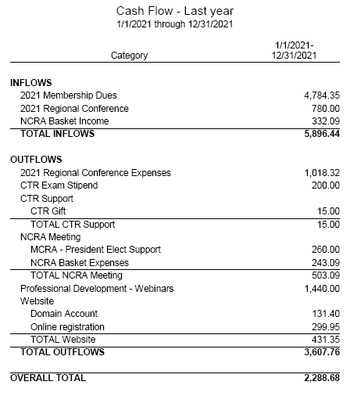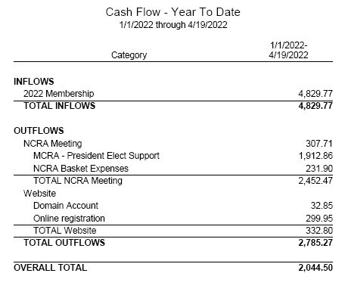

Bylaws Update

By Linda Vanstrom, CTR

Did you know that, not only the Executive Committee, but also individual members, can propose amendments to the MCRA Bylaws? According to Article X – Section 1 Proposal of Amendments:

Amendments to these Bylaws may be proposed by any MCRA Committee. Individual voting members may propose amendments provided such proposals are accompanied by the written endorsement of at least two (2) additional voting members of MCRA. All proposals for amendments shall be submitted to the Bylaws Committee Chairperson who shall present them to the Bylaws Committee and then to the Executive Committee. Proposed amendments which receive approval of the Executive Committee shall be submitted to the MCRA membership.

After logging into the MCRA website, the current Bylaws can be found in the Documents section.

Communications

By Breana Norton, BA, CTR

As the Communication Chair, I send emails from the MCRA executive board to the MCRA membership and put together the MODMM bi-yearly. If you have any suggestions about the MODMM or have any questions concerning emails from the MCRA, please feel free to reach out to me. Thanks!

MCRA Website | mcra.net

By Thomas Coles, CTR, CHES - The Website Guy

The MCRA Website is continually being updated with the most currently released NAACCR Webinars, recent job postings, MCRA newsletters, among other important website-worthy tidbits. As always, feel free to reach out to me if you have any questions, comments, or concerns. Thanks!

Coding Corner

By Jennifer L. Nelson, CTR, NR-EMT - MCRS Liaison

Welcome to the first edition of Coding Corner. Please submit your questions, suggestions or helpful hints to Jennifer Nelson at Jen.L.Nelson@state.mn.us

1. Low-grade appendiceal mucinous neoplasm (LAMN)
   1. Low-grade appendiceal mucinous neoplasm became reportable beginning with 1/1/2022 diagnoses
   2. Assign behavior code of /2 when confined to muscularis propria
   3. Assign behavior code of /3 when extending into subserosa or serosa
   4. Per SEER Program Coding and Staging Manual 2022 they are slow growing with potential for peritoneal spread and can result in patient death
   5. For more information please see:
      1. <https://seer.cancer.gov/manuals/2022/SPCSM_2022_Appendix_E.pdf>
      2. <https://www.naaccr.org/wp-content/uploads/2022/03/2022-Implementation-Guidelines_20220317.pdf>
         1. There are 11 references to LAMN in the Implementation Guidelines including coding histology as 8480
2. Suspicious cytology – Change for 2022
   1. For 2022 and forward the date of suspicious cytology IF FOLLOWED by a definitive diagnosis may be used as the date of diagnosis
   2. Page 10 of the SEER Program Coding and Staging Manual 2022 states: Do **not** accession a case based ONLY on **suspicious** cytology. Follow back on cytology diagnoses using ambiguous terminology is strongly recommended. Accession the case when a reportable diagnosis is later confirmed. The date of diagnosis is the date of the suspicious cytology.
      1. SEER Program Coding and Staging Manual 2022 provides 9 references. For further details please see: <https://seer.cancer.gov/manuals/2022/SPCSM_2022_MainDoc.pdf>
3. Chondrosarcoma, grade 1 – 9222/3
   1. Reportable 1/1/2022 and forward as behavior code changed to /3
      1. Reference:

https://www.naaccr.org/wp-content/uploads/2021/12/2022-Implementation-Guidelines_20211129.pdf

1. Nerve Sheath Tumors
   1. Malignant peripheral nerve sheath tumors are rare. They occur in the lining of the nerves/sheath that covers the peripheral nerves. Can occur anywhere in the body, but a majority of the time are in the deep tissues of the trunk, legs and arms. Usually treated with surgery but radiation and chemotherapy may also be recommended.
      1. For further information please see National Cancer Institute’s website: <https://www.cancer.gov/pediatric-adult-rare-tumor/rare-tumors/rare-soft-tissue-tumors/mpnst>
   2. Solid Tumor Rules Manual: Malignant CNS and Peripheral Nerves Section 2: Reportable Primary Sites and Histologies states:
      1. Note 1: Peripheral nerves are included in the Malignant CNS and Peripheral Nerve rules because: • All malignant tumors are reportable, including peripheral nerve tumors AND • The Malignant CNS and Peripheral Nerve rules contain the correct histologies and coding rules for tumors of peripheral nerves and meninges/dura.
      2. Note 2: Peripheral nerves are: • Extracranial/outside the cranium OR • Extradural/outside the spinal dura
   3. Please see the following references for help with coding histology and/or primary sites:
      1. NAACCR’s ICD O 3.2 Coding Table: <https://www.naaccr.org/wp-content/uploads/2020/10/Copy-of-ICD-O-3.2_MFin_17042019_web.xls>
      2. Solid Tumor Rules for peripheral nerves and nerve sheath sites and/or histology codes: [Malignant CNS Solid Tumor Rules (cancer.gov)](https://seer.cancer.gov/tools/solidtumor/Malignant_CNS_STM.pdf)
      3. If you still have questions, please contact your MCRS Field Service Representative

MCRA Member Spotlights

By Jackie Halsey, CNMT, CTR; Breana Norton, BA, CTR

We wanted to get to know some of our new MCRA members and asked a few of them to share a little bit about themselves via a questionnaire. We are grateful for their willingness to participate.

Meet Jennifer Leisenheimer, RHIT, CTR

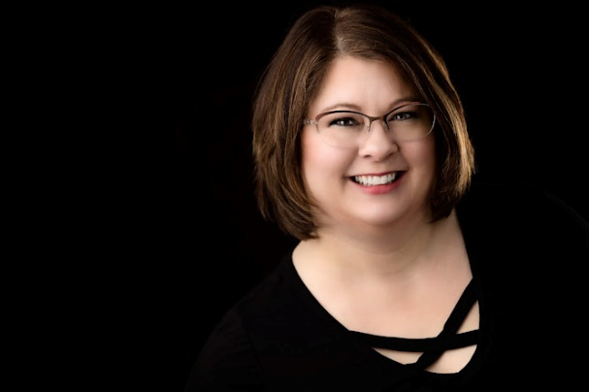I've been married to Karl for almost 24 years. We live in Bemidji, MN. We have 2 daughters - Hayley, 22, who is a senior at North Dakota State University majoring in Human Development and Family Science and plans to be a child life specialist. Our youngest daughter, Hannah, is 21 and is finishing her first year of graduate school at University of North Dakota to become an occupational therapist. We have a black lab named Lexi and a grumpy kitty named Isabella.   
  
Q: What is your current job and what are some of your job duties?

A: I am currently a CTR at Mayo Clinic Arizona, formerly at Sanford Health Fargo and began at Mayo Clinic in March 2022. I work as an abstractor for hematologic malignancies such as leukemia, multiple myeloma, and lymphoma. I've been a CTR since October 2020 and I'm so proud of the work I do! Prior to my career in cancer registry, I was a CHDS in medical transcription for 18 years.

Q: What do you love most about the cancer registry profession?

A: Cancer has taken the lives of nearly all of the people I've lost in my life. I have seen the toll it takes on its victims and their families and friends. I am not a doctor or researcher and cannot save anyone from cancer. However, if the data that I abstract and submit to state and national registries someday helps a parent get extra quality time to spend with their children, helps a grandparent see a grandchild graduate or walk down the aisle, or helps give a child a second chance at life and a chance to grow up, then it will all have been worth it. Plus, I love "putting the puzzle together" when abstracting patient data. Each abstract is a new adventure!

Q: What is something people don't know about you?

A: I am a self-published author! I've always loved writing and took a leap of faith in 2015, publishing a novella as part of a series, and went on to publish a second novella in another series. I write under the pen name Jenn Braddock. I have a full-length novel in the works that I hope to publish eventually. However, with a full-time job and two girls in college, it's hard to find the time to write!

Q: What is the next place on your travel bucket list?

A: My husband, Karl, and I have plans to celebrate our 25th anniversary next year with a trip to Maui, a place I've never been but always wanted to go. Also on my bucket list in the next few years is a trip to Italy to visit the Vatican, experience the amazing cuisine throughout the country, to see the Amalfi coast, and hopefully a quick stop in Greece to see Santorini.

Q: What is one item you can't live without?

A: On a daily basis, the answer to that is coffee. I'm useless without my morning coffee and my occasional trip to Caribou (dark chocolate Mint Condition is my jam!). But aside from my family and pets, the one thing I would be heartbroken to live without would be my flute. I've had it since the 8th grade, it's been so many places with me and we've been on so many adventures together, I'd be crushed to lose it. I always know where it is in my house in case of a fire; it would be one of the first things I'd grab if able. It also has a lot of sentimental value in that my late father sold a favorite hunting rifle to buy it for me.

Q: What is your 15 minutes of fame?

A: Related to the last question above, I had the honor of playing in the MN All-State band when I was a senior in high school. We got to perform at Orchestra Hall in Minneapolis, and it was a true highlight of my life. To share the stage where just two years before I had watched my idol, James Galway, perform was a dream! We sat front row center for his concert and he stood directly in front of me. I'll never forget either experience! Sidenote: I did get to meet him in person years later at another concert at Orchestra Hall!

Q: What is the strangest thing you've ever done?  
A: Well, I'm going to change this up a bit to say the strangest thing that ever happened to me. I met my husband during a bomb threat! I was working in a bank in my mid 20s, and a co-worker, my husband's loan officer, decided that we would make a good couple. So, on the day that he was to come in to sign some paperwork on a home he was buying, she was going to introduce us. However, minutes before the introduction was to happen, we were told to evacuate the bank due to a phoned-in bomb threat...the ONLY one in the bank's more than 120-year history (totally unrelated to our meeting). As we evacuated to our nearby fire hall, I noticed that his loan officer had brought him with her! With his permission, she introduced us as we waited for the all-clear, and the rest, they say, is history. Made a great story to tell our kids when they were older!

Meet Cherol Young, RHIT, CTR

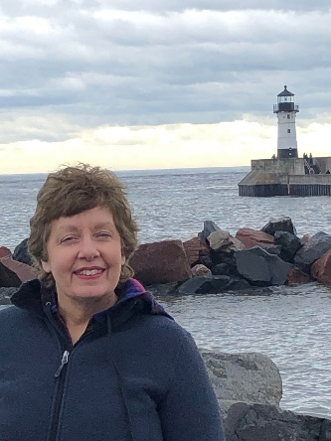Q: What is your current job and what are some of your job duties?

A: My current job is at Allina Health as a CTR.  My main duties are case finding, coding/abstracting cases, and tumor conference for Lung and Neuro.  I mainly abstract Brain/Spinal Cord, Lung, Endometrium, and Hemat/Lymphoma

Q: What do you love most about the cancer registry profession?

A: I love that I am constantly learning!  Each case is unique and some cases are a real challenge.

Q: What is something people don’t know about you?

A: I love demolition derbies!

Q: What’s the next place on your travel bucket list?

A: I have three top places that I hope to get to someday: Yosemite National Park, Italy, and Aruba!

Q: What’s one item you can’t live without?

A: When my husband Mike and I do out of state road trips, I have to have good old fashioned paper maps that I can refer to!  It drives Mike nuts being he loves GPS.  Mike refers to it as my Christopher Columbus maps.  J

Q: What was the worst job you have ever had?

A: My worst job was working 3rd shift at a plastics factory during a summer break from college.  I am not a night person so my summer was just sleeping and working in a very hot environment.

Q: What is your 15 minutes of fame?

A: My 15 minutes of fame is this!

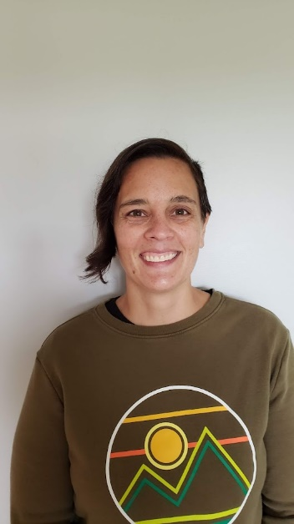Meet Breana Norton, BA, CTR

Q: What is your current job and what are some of your job duties?

A: I am currently working at M Health Fairview where I am the CTR for their Range Hibbing facility. I am also the MCRA Communications Chair.

Q: What do you love most about the cancer registry profession?

A: I love being a perpetual student and I quickly realized that as a CTR the field and the research is ever changing and developing.  I love that the CTR field intrinsically gives us the opportunity to always be growing and learning.

Q: What is something people don’t know about you?

A: I used to be fluent in Spanish. I lived in Central America for 2 years total where I worked for multiple humanitarian foundations and then I got my undergrad in Spanish. I unfortunately did not keep up with it, but still love to read children’s books in Spanish.

Q: What’s the next place on your travel bucket list?

A: I would love to visit Costa Rica to visit a sloth reserve. Generally, I am always wanting to visit anywhere in the Caribbean.

Q: What’s one item you can’t live without?

A: A swimming pool and/or yoga mat. I was on a high school swim team and have been swimming off and on ever since. When I can’t get to the pool (especially during the pandemic shutdowns) I have been exploring yoga.

Q: What was the worst job you have ever had?

A: I have generally loved all my jobs I’ve had, but I will never forget the multiple times I had to clean up human feces working as a lifeguard at a swimming pool.

Q: What’s the strangest thing you’ve ever done?

A: I was an Anatomy TA for a lab for 2 years in college where I taught students how to correctly identify and name anatomy from donated human cadavers. I also took a dissection class where I was able to dissect a lower limb down to the muscle fibers to showcase the muscles and tendons that move the foot and toes.

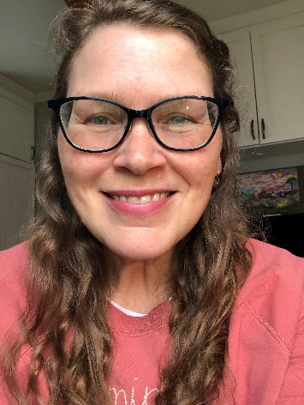Meet Julie Heyd, MS, BA, CTR

Q: What is your current job and what are some of your job duties?

A: I am a CTR at Methodist Hospital. I mainly abstract head and neck, pancreas, lung, CNS, hematopoietic and thyroid cancers. I help do the case-finding for those sites as well.

Q: What do you love most about the cancer registry profession?

A: I love finding out the story of each cancer, doing a little detective work, and organizing and categorizing the data. I also love the ability to work from home.

Q: What is something people don’t know about you?

A: I haven’t eaten meat in over 30 years.

Q: What’s the next place on your travel bucket list?

A: Iceland

Q: What’s one item you can’t live without?

A: Coffee

Q: What was the worst job you have ever had?

A: Burger King

Q: What is your 15 minutes of fame?

A: I’m a published author with an article in the journal, Statistics in Medicine

