Minnesota Cancer Registrars Association

## THE MODMM

## The Minnesota Oncology Data Managers Monitor

**PRESIDENTS MESSAGE**

Message to Members

This year provided challenges we couldn’t have imagined. Fortunately, I was able to attend the NCRA conference and the WCRA/MCRA regional conference. Unfortunately, they were both virtual events. While the amount of knowledge and learning happening at these events is insurmountable, it can’t replace the connections made among fellow CTRs. I remain hopeful that future conferences can go back to in-person conferences.

I’m not sure how I can begin to share some of this information with you as it would be quite lengthy…so I’m going to pick out a few that really stood out to me.

* The first being the NCRA COVID-19 Survey. NCRA wanted to understand how cancer registrars and the tasks they perform have been affected by the COVID-19 pandemic. An online survey was distributed between May 4th–May 11th, 2020, to 638 registrars. A total of 395 registrars responded for a response rate of 61.9%. More than four in 10 respondents (40.7%) say their monthly caseload has decreased since February 2020, while just over one-third (33.6%) say it has stayed the same. More than one-fifth (22.6%) are unsure, and just 3.1% have observed an increase. The most commonly cited change in work is that personnel who normally work in the cancer registry are now working from home (66.6%). While 57.5% say that personnel who normally work from home are continuing to work from home, a proportion nearly as large (50.6%) report that personnel who normally work in the cancer registry continue to do so. Furthermore, 43.1% say personnel have not had their work impacted by COVID-19. I have this full report available, broken down by question with responses and comments. If anyone is interested in it, I would be happy to share it.
* I also had the privilege of participating in the SSDI study – which they provided results for. In general, the registrars who participated, did well on the SSDIs and ‘yc’, however there were still some issues with the neoadjuvant data items. Overall, it was helpful for registrars to identify areas for the work group that needs more specific details and/or clarification.
* NAACCR has provided a link in their 2021 Implementation guidelines to the new version of ICD-O-3.2 manual.
* Beginning with 2021, there will be less SSDIs for breast cases
* SEER moving towards non-traditional data sources – how cancer patients are diagnosed and managed is changing at a pace that is so rapid it is extremely difficult to keep up to date. Detailed treatment: linkages for treatment from pharmacies, biomarkers linkages and recurrence data.
* RQRS going from 3 sites with 3 measures each to RCRS with 13 sites for CP3R
* Standards clarifications – additional guidance is provided with new webinars available for understanding some of the new material – for example, the Operative Standards for Cancer Surgery (Standards 5.3-5.8). Check out the CoC website.
* Posttherapy staging: 3 type of neoadjuvant therapy patients:

|  |  |  |  |
| --- | --- | --- | --- |
| **Initial treatment** | **Response to neoadjuvant** | **Further planned treatment** | **AJCC Staging** |
| Neoadjuvant | Good | Surgical resection | yp |
| Neoadjuvant | No response | Surgery canceled | yc |
| Neoadjuvant | Excellent response | No surgery needed | yc |

* Beginning in 2021, the CoC will be collecting yc staging
* Radiation items: Cone down is the same as boost = interchangeable terms. Proton therapy – typical sites = base of skull, spinal cord, pediatrics. AP/PA – technique is 3D. Radiation Oncologists are required to submit an “end of treatment” summary – however, they don’t all get to them.
* Text: not just for teenagers! NAACCR has an abbreviation list posted on their website. Many states to as well. Make sure your text is “quality”. ‘Operative Findings’ text: this will often be “procedure only” or N/A. You don’t document the type of surgery here or pathology. This is where you’d document findings during surgery. Strategies to Avoid Common Abstracting Errors: Commit to learning just a few abbreviations at a time. Prostate core biopsies – only need to text the highest core, x of xx cores positive, etc.
* For benign brain/CNS tumors only (behavior 0), grade code 1 can be automatically assigned for all histologies.
* Triple positive cT2 cN0 cM0 breast tumor, stage would be 1B regardless of grade.

This last little tid-bit of information seemed fascinating to me and I can’t even explain why it didn’t dawn on me before. For nodal stages of the lung, mediastinal nodes are all single digit stations (1-9) and hilar nodes are double digit stations (10+).

I know this is a small fraction of the items presented at NCRA but I hope I shared at least one new thing for you. I have also added these 2 pictures from the slides for head/neck that may be beneficial.

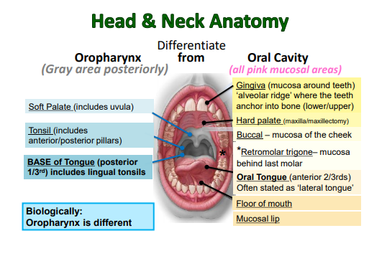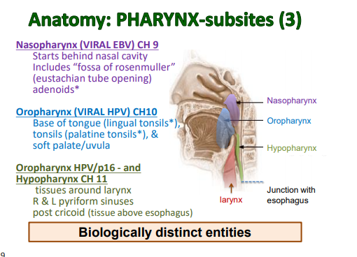

I sincerely hope and pray that you and your families have a happy, healthy holiday season!

Jess Klaphake, RHIT, CTR

MCRA President

**National Cancer Registrars Week -- April 5-9, 2021**

Cancer registrars throughout the world will join their colleagues, fellow medical professionals, and community leaders to observe the 25th annual National Cancer Registrars Week (NCRW), April 5-9, 2021. The purpose of NCRW is to emphasize the important role cancer registrars play in capturing the data that informs cancer research, prevention, and treatment programs. The theme for 2021 is "Cancer Registrars: The Driving Force of Cancer Data." A special NCRW packet will be mailed in February to all NCRA members. It will contain the NCRW 2021 poster, press release, and a special gift to commemorate the week. Keep up to date on NCRW materials and events at [**www.ncra-usa.org/ncrw/**](https://nam10.safelinks.protection.outlook.com/?url=http%3A%2F%2Fr20.rs6.net%2Ftn.jsp%3Ff%3D0014FapK-50eRjFRIZzPIr9Ahyos0KvxCNV81Ptw0pQ8n_pSSQOB4qEYDBG6zPMj5BeAgP7gy6qw6-QhmKpKkMhAlb9zpy076Q3a7jZhU-HkyzOc0ygSZ-naUuBqS1fk0dVbvh5E7niEisK0RgBarqxYu_92izS92Cc27ifyzsz6H8JSVWasucgEA%3D%3D%26c%3DBcbLLJLIW3v_UWWEL1AaSnt3FB2CcvRV4VQaY8FetehPk9c_mhxTIA%3D%3D%26ch%3DTqXl-Hv4jGM-8t41f2TimDuTp7Rnwo6OkGwmgJhWI5CLxSrxZe47Yw%3D%3D&data=04%7C01%7Cklaphakej%40centracare.com%7C9c9812dbe61b402f747108d89ae27b1c%7C1c45913baa5f4d3b9bfc987ab127fe57%7C0%7C0%7C637429644807848205%7CUnknown%7CTWFpbGZsb3d8eyJWIjoiMC4wLjAwMDAiLCJQIjoiV2luMzIiLCJBTiI6Ik1haWwiLCJXVCI6Mn0%3D%7C1000&sdata=OvvO0BR0cT2PzvioTo4SJ2vsojPubf6349sMCkV19Yo%3D&reserved=0).



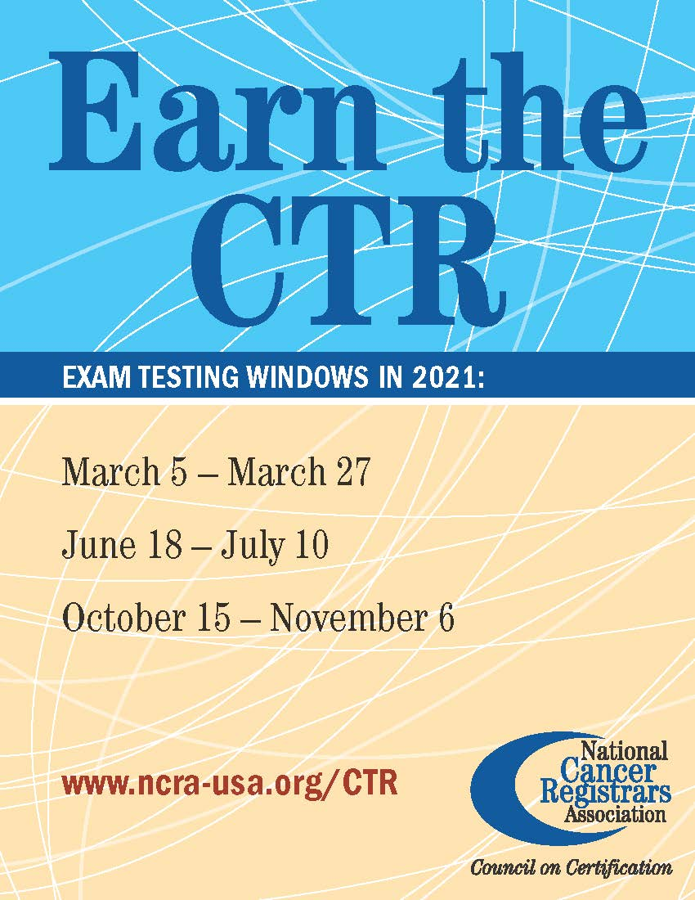

**NOMINATING COMMITTEE**

Submitted by

**Nominating Committee**

Erin Hammell, RHIT, CTR

Nancy Hedstrom, RHIT, CTR

LeeAnn Olson, CTR

Jen Nelson, CTR, NR-EMT

The nominating committee is looking for volunteers and/or nominations for executive board positions for 2021. *Please strongly consider volunteering so that we may keep our organization running smoothly.*

**Eligibility:** Any member in good standing for one full year prior to nomination shall be eligible to hold office. To be eligible for the office of President-Elect, a member must have served one full term on the Executive Committee prior to nomination.

**These are the positions open for 2021/2022:**

**President-Elect:** Shall assume the duties of the President in his/her absence and shall succeed to the office of President at the conclusion of his/her term of office. The President-Elect shall co-chair the Professional Development committee. Ensure website information is correct.

**Secretary:** Shall be responsible for records of all MCRA proceedings and shall distribute minutes of all business meetings to the membership.

**Treasurer:** Shall be responsible for the receipt and disbursement of all funds of MCRA and shall make written reports to the Executive Committee and to the membership. The treasurer shall serve on the Membership Committee.

**These are the committees needing volunteers for 2021/2022:**

**Professional Development Committee:** Shall be Responsible for leadership in the Professional Development of MCRA membership. It shall include the President-Elect, with responsibility for educational programs. It will include persons responsible for support of members seeking CTR status, and any other members as deemed by the President or the Executive Committee.

**Communications Committee:** The Communications Committee will include persons responsiblefor the MCRA newsletter, the MODMM (The Minnesota Oncology Data Managers Monitor) and for taking photographs. Liaisons to the Minnesota Cancer Council, National Cancer Registrars association, Minnesota Health Information Management Association, Commission on Cancer, Minnesota Cancer Surveillance System, Others as felt necessary, in order to carry on the responsibilities of the communications committee.

**Website Coordinator:** Shall be responsible for working with the Webmaster to ensure smooth operation of the MCRA website.

**Nominating Committee:** There shall be at least four members on the Nominating Committee, the chairperson (appointed by the newly elected President), the immediate Past-President, and two other members elected by the MCRA at the April (Spring) Annual Meeting. They are responsible for preparing, mailing, and tallying the ballots in accord with Article V. No member of this committee shall be eligible for office.

**Membership Committee:** Shall be responsible for acceptance of new members and for distribution of updated rosters to the members. The MCRA Treasurer shall be a member of this committee and provide updated information on payment of dues.

If you are interested in volunteering and/or nominating anyone for any of these positions please contact one of the above nominating committee members.

Thank you for your consideration in fulfilling these positions,

Erin Hammell

Nancy Hedstrom

Leeann Olson

Jen Nelson

**BYLAWS**

Linda Vanstrom

Bylaws can be found on the MCRA website: click on the “Documents” tab, then the hyperlink for “MCRA Bylaws”.

**MEMBERSHIP**

Chunny Daiker

Renewal is February 1st and renewal will be similar to past years.

## We Are Professionals Who

Manage data describing the diagnosis and treatment of cancer.

Promote quality cancer data collection and cancer program management.



**TREASURER’S REPORT**

Submitted by Amanda Hlad, RHIA, CTR



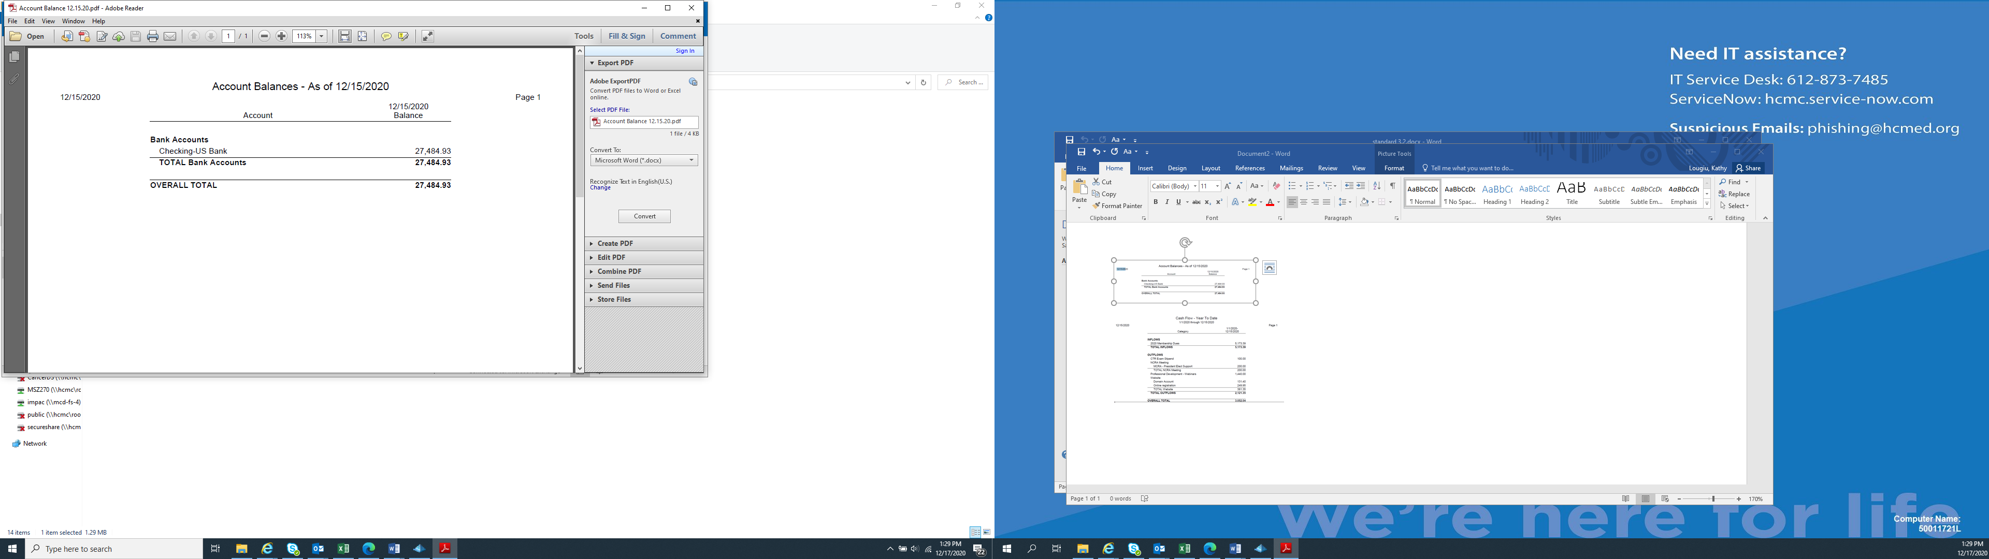

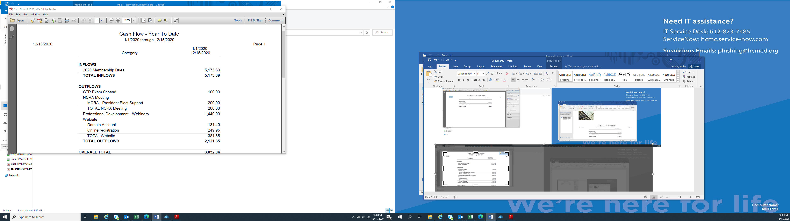

**WEBSITE**

Submitted by Tom Coles

The website continues to be updated with NAACCR webinars as they are released for viewing.

**PROFESSIONAL DEVELOPMENT**

Candace Scherping, Heidi Leach, Melanie Nelson, LaurelLyytinen



The planning group for MCRA/WCRA Regional Conference met to start discussions on the regional conference for next fall.  Planning to likely conduct as a virtual event again.  A survey has been sent out out for date preference please be sure to respond and another one will come out for speakers, topic ideas etc.  watch for that.

The 2021 CTR exam testing windows was on the email attachment I sent yesterday.

COMMUNICATIONS

Submitted by Kathy Lougiu, CTR



NCRA’s 47th Annual Educational Conference will be held June 2-5, 2021, at the J.W. Marriott in Indianapolis. The theme is “Driving Cancer Data into the Future.”

Details on the conference program and registration information will be available in January 2021.



**MCRS Updates:**

Submitted by Carol Forbes-Manske, CTR

**ICD-O Update Changes – Reportability Changes as of 1/1/2021** – There are many ICD-O changes for 2021 –

* New reportable conditions in 2021, including some that were non-reportable prior to 2021 that are now reportable.
* Previously reportable conditions that are non-reportable in 2021.

Please review Table 6: Combined 2021 ICD-O-3.2 update (numerical) or Table 7: Combined 2021 ICD-O-3.2 update (alphabetical) when determining reportability.

**Do not rely on your memory of what has been reportable or non-reportable prior to 2021.**

The 2021 ICD-O-3.2 Coding Updates Table is to be used jointly with ICD-O-3.2, the Solid Tumor Rules, and the Hematopoietic & Lymphoid Database.

* + ICD-O-3.2 is the preferred reference for morphology codes and is available in Excel format only.

**Pathologic Staging of DCIS without LN Excision** – Per CAnswer Forum, 8/12/20 post – you can assign pathologic values of pTis cN0 (for no nodes removed) cM0 for DCIS without pathologic node evaluation.

**Death Clearance Follow-Back – Why We Do It** – MCRS does Death Clearance Follow-Back on MN death certificates listing a cancer or benign brain/CNS tumor that is not in our database and the address of the person is either MN or unknown. This is a monumental task as often times we only have a nursing home or physician listed to contact for follow-up. In our efforts to determine if the cancer was reportable and if the person was a MN resident at time of diagnosis, we often times review records from the nearest hospital/clinic to the address at time of death. From there, we send letters to the nursing homes or physicians requesting additional information. We do not always get good information, or any information, from these follow-back letters. Thus, we continue reviewing records from hospitals/clinics or making phone calls to ascertain where and when the person was diagnoses and their address at diagnosis.

**NPCR Data Quality Evaluation** – MCRS is required as part of the NPCR program to undergo a DQE at least once every 5 years. This year female breast, colorectal, lung and bronchus, corpus uteri, and prostate cases from diagnosis year 2017 were reviewed by an organization under contract to CDC.

Problem areas: Grade, Surgery of Primary Site, Systemic/Surgery Sequence, TEXT, TEXT, TEXT – documentation in text fields was either completely missing or incorrectly coded based on the text.

Percentage of Major Errors by Category, All Sites Combined – Cancer Identification 14%, Staging/Prognostic Factors 22%, and Treatment – 64%.

**On to Greener Pastures** – Jo Bitker retired from MCRS on October 16th. She had been with MCRS since 1988 and had a lot of knowledge of the workings of MCRS in the early days (when we were MCSS) and a keen mind for keeping the history of all the changes. She is greatly missed by her co-workers and contacts.

**COVID-19 Pandemic** – As Minnesotans and people around the world continue to battle COVID-19, MCRS is still down staff that have been reassigned to work COVID-19 response. The latest news is that reassignments will last through June of 2021 and more of us may be called up for response. Please bear with us. Staff will respond to your emails and phone calls as soon as possible.

**Staffing Change** - Jen Nelson will be the MCRS educator/trainer effective January 1, 2021.

**Facility/Regions Changes Possible** – The current regions and facilities assigned to MCRS staff will be reviewed and changes may be made regarding Field Service staff having which facilities. Stay tuned for more information. If your MCRS Field Service representative changes, you will be contacted.

**Follow-Up from WCRA/MCRA Conference**

**Breast – Surgery Coding for Uninvolved Contralateral Breast** – Question/Answer in CAnswer Forum:

CAnswer Forum, STORE, Surgery, Coding Uninvolved Breast Mastectomy in Surgery Other Site, 10/27/20

**CAnswer Forum Answer**: When the contralateral uninvolved breast is being captured in the surgical code assigned, you do not pick it up again in the Surgical Proc/Other Site. If the patient had a Total Mastectomy w/removal of the uninvolved contralateral breast, assign code 42.

**Laterality for Midline Trunk** – 5 vs 9. Subject: Solid Tumor Rules (for cases diagnosed 2018+) Question sent to Ask a SEER Registrar. **Ask a SEER Registrar Answer 11/19/20**: Assign laterality code 5 (midline) for a cutaneous melanoma of midline trunk/back. . Laterality code 5 became effective with cases diagnosed 01/01/2010 and is applicable to any case diagnosed after that. See the example on page 93 in the SEER manual.

**MCRS’ Answer**: For midline melanomas of the skin, code laterality 5 (midline).

**Who Can Submit Questions to Ask a SEER Registrar** – any registrar can submit a question to Ask a SEER Registrar. Only SEER regions can submit technical questions to NCI SEER inquiry system using SINQ. MN is not a SEER region.

**TEXT, TEXT, TEXT** – text should support your codes and vice versa.

PE: *Patient age*, *ethnicity, race, sex, reason for visit. PE results or PE wnls.*

Dx Proc Scope: *Date,* *Type of scope & findings*

Dx Proc Op: *Date, Type of procedure (i.e. if surgery >4 months after diagnosis but was planned, document that in text). Remember, if patient on active surveillance but decided on treatment prior to 1st follow-up visit with MD, that is 1st course treatment & should be documented in text.*

Xray/Scan: *Date, Name of xray/scan, results.*

Path: *Date, Final Diagnosis, TS, depth of invasion, etc.*

DX Proc Lab Test: *Date, name of test, result, normal/high.*

Radiation Treatment: *Date,* *type of RT,* *site*, *dose, # fractions, modality, boost dose, # fractions, modality*.

Chemo/Hormone/BRM/Hemo/Endo/Other Treatment: *Date,* *name of drug(s) or reason none if appropriate, i.e. died prior to treatment, not recommended due to comorbidities, etc.*

* *Per the WCRA/MCRA Conference, if patient on active surveillance but decided on treatment prior to 1st follow-up visit with MD, that is 1st course treatment & should be documented in text.*
* *According to SEER Program Coding & Staging Manual 2018, Treatment Planning, page 148, When there is* ***no documentation*** *of a treatment plan or progression, recurrence or a treatment failure, 1st course therapy ends one year after the date of diagnosis.*

**CODING CORNER**

The 2021 ICD-O-3.2 Update is available at <https://www.naaccr.org/icdo3/>. Familiarize yourself with these tables and refer to the Update Tables often when assigning histology codes.

Table 1 lists new behavior codes (reportable neoplasms) for diagnoses 1/1/2021 forward. Some of the reportable codes include:

* Aggressive digital papillary adenoma (8408/3)
* Beta cell adenoma, C25.4 (8151/3)
* Early/Evolving invasive melanoma (8720/3)
* Early/Evolving melanoma in situ (8720/2)
* Endocrine tumor, functioning, NOS (8158/3)
* Erdhiem-Chester disease (9749/3)
* Extra-adrenal paraganglioma, NOS (8693/3o
* Gastrointestinal autonomic nerve tumor (8936/3)
  + GANT (8936/3)
  + Gastrointestinal pacemaker cell tumor (8936/3)
  + Gastrointestinal stromal tumor (8936/3)
* Granulosa cell tumor, adult type, C56.9 (8620/3)
* Insulinoma, NOS, C25.4 (8151/3)
* Islet cell adenoma, C25.4 (8150/3)
  + Islet cell adenomatosis, C25.4 (8150/3)
  + Islet cell tumor, NOS, C25.4 (8150/3)
* Laryngeal paraganglioma (8693/3)
* Lymphomatoid granulomatosis, grade 3 (9766/3)
* Mucinous cystic neoplasm with high grade dysplasia, C25._ (8470/2)
* Pancreatic endocrine tumor, nonfunctioning, C25.4 (8150/3)
  + Pancreatic endocrine tumor, NOS (8150/3)
* Pancreatic neuroendocrine tumor, nonfunctioning, C25.4 (8150/3)
* Paraganglioma, NOS, C75.5 (8680/3)
* Pheochromocytoma, NOS, C74.1 (8700/3)

Table 2 lists new behavior codes for non-reportable diagnoses beginning with 2021 diagnoses forward. Some of the new non-reportable codes include:

* Dermatofibrosarcoma protuberans, NOS (8832/1)
  + Pigmented dermatofibrosarcoma protuberans, C44._ (8833/1)
* Dermatofibrosarcoma, NOS (8832/1)
* Hydroa vacciniforme-like lymphoproliferative disorder (9725/1)
* Immature teratoma of the lung, C34._ (9080/1)
  + Immature teratoma of the thymus, C37.9 (9080/1)
  + Immature teratoma of the thyroid, C73.9 (9080/1)
* Langerhans cell histiocytosis, NOS (9751/1)
  + Langerhans cell histiocytosis, monostotic (9751/1)
  + Langerhans cell histiocytosis, polystotic (9751/1)
* Polymorphic post-transplant lymphoproliferative disorder (9971/1)
* Post-transplant lymphoproliferative disorder, NOS (9971/1)
  + PTLD (9971/1)
* Primary cutaneous CD30+ T-cell lymphoproliferative disorder, C44._ (9718/1)
* Primary cutaneous CD4-positive small/medium T-cell lymphoma, C44._ (9709/1)



Meet the 2020 MCRA Executive Committee

**President - Jess Klaphake**, RHIT, CTR – *President-Elect:* St. Cloud Hospital/Coborn Cancer Center, St. Cloud. Member since 2014.

**President Elect – Jackie Halsey,** CNMT, CTR, Rochester Communtity & Technical Colleger, Rochester. Member since 2010

**Past President, Jen Nelson**, CTR, NR-EMT –past *President:* MN Cancer Surveillance System, St. Paul. Member since 2011.

**Kathy Lougiu,** CTR – *Communications & MODMM:* Hennepin Healthcare. Member since 2014.

**Linda Vanstrom**, RHIT, CTR – *By-laws:* Minneapolis VA Health Care System, Minneapolis. Member since 1994.

**Amanda Hlad**, RHIA, CTR – *Treasurer:* St. Joseph’s Medical Center, Brainerd. Member since 2007.

**Julie Heyd,** CTR– *Secretary:* Rochester Community & Technical College, Rochester. Member since 2010.

**Carol Forbes-Manske**, CTR – *MCSS Liaison:* MCSS, St. Paul. Member since 1986.

**Chunny Daiker**, BS, RHIT, CTR – *Membership:* Hennepin County Medical Center, Minneapolis. Member since 2009.

**Tom Coles**, CTR, CHES – *Website:* Allina-Abbott Northwestern Hospital, Minneapolis. Member since 2009.

**Erin Hammell (Chair), Jen Nelson, Nancy Hedstrom, LeeAnn Olson** – *Nominating Committee*

**Jackie Halsey, Cindy Sanborn, Jess Klaphake**– “Laurie Griffin *Outstanding Member” Award Committee*

**Candace Scherping**, **Heidi Leach, Melanie Nelson, Laurel Lyytinen**– *Professional Development*