Minnesota Cancer Registrars Association

## THE MODMM

## The Minnesota Oncology Data Managers Monitor

**PRESIDENTS MESSAGE**

**President’s Message**

When I was nominated for President-Elect over a year ago, I had no idea my term as President would look quite like this plus, I expected to be sharing knowledge I gained at the 2020 NCRA Conference in Florida. Instead, I am sharing some of MY knowledge with students in the Cancer Registry program at RCTC. Over the past couple years, it became evident to me that I had a real passion for education so when Jackie asked if we could take a “virtual” student, I instantly said yes. With the additional challenges COVID-19 added to employers, educators, etc., we had to get creative and think outside-the-box. I was honored to share my experience from a CoC survey with those students, as well as the registry world as it pertains to my facility, all via a zoom meeting. As scary as I thought it would be, stepping out of my comfort zone was exhilarating! In one of the sessions, I was able to share how we enter an abstract into our software, looking through the different manuals to show the how and why of the codes and run edits on the case. Sharing your information or showing a student how to abstract will help the student earn credit towards their practicum while enhancing “real-life” knowledge in our field. Are you interested in sharing your experiences with CTR eligible students? Perhaps you want to create a fictitious patient with a cancer diagnosis and show students how you enter it into your registry software? Did Yosemite Sam have multiple tumors? Or maybe Woody Woodpecker had multiple comorbidities. Demonstrate how to use the manuals while coding different scenarios. I encourage you to reach out to Jackie Halsey at RCTC if you are interested.

This fall, WCRA will be hosting the Regional Conference as a virtual conference. Registration for this conference will be offered free of charge to MCRA and WCRA members due to sponsorship money WCRA received last year. CE’s will be offered, and certificates sent out. The brochure and registration link were emailed out by Kathy Lougiu on Friday July 10th. The MCRA business meeting and state updates will be held as usual. On that note, please let me know if there is anything you want added to the business meeting agenda.

Also this fall is the Virtual NCRA conference and topics appear to be interesting. I am “virtually” excited to attend and share new information on the next newsletter! The planning committee is planning to do an online basket raffle. If it is feasible, consider attending this National conference at a much lower rate.

As we navigate through our new every day normal, always strive to see the positives in situations. Greater than a year ago, I purchased paint in hopes to paint the outside of our house and shed. While I struggled with all the cancelations of trips we had planned and sporting events and distance learning, I realized that this pandemic gave me the free time to get this task completed. Stay-at-home orders allotted me the time to focus on my own well-being and spending extra quality time with my children. While I am not thankful for the pandemic or people falling ill or dying, I am thankful for the extra time I was given.

I look forward to serving MCRA in the capacity of President for the remainder of 2020 and 2021.

Sincerely,

Jess Klaphake, RHIT, CTR

MCRA President

**NOMINATING COMMITTEE**

Submitted by

**Nominating Committee**

Nancy Hedstrom, RHIT, CTR

Carol Forbes-Manske, CTR

Erin Hammell, RHIT, CTR

LeeAnn Olson, CTR

**BYLAWS**

Submitted by Linda Vanstrom

The Annual Spring Business Meeting was held by conference call on 4/17/20. The following changes to the MCRA Bylaws were voted on and approved by the members present on that call:

Article VI – Section 2 – Annual Business Meeting

The Annual Business meeting was moved from Spring to Fall to be held in conjunction with the Fall Workshop.

Article V – Section 5 – Election of Officers

Section 5A – The electronic voting site will be prepared by July 15th

Section 5C – Balloting will be completed by August 15th

Section 5D – Results of the election will be announced in September

As a result of these changes, the current officers will remain in their respective positions until successors are elected and installed at the 2021 Fall Workshop.

## We Are Professionals Who

Manage data describing the diagnosis and treatment of cancer. Promote quality cancer data collection and cancer program management.

**OUTSTANDING MEMBER AWARD**

Submitted by Jackie Halsey, Cindy Sanborn, Jess Klaphake

We are accepting nominations for MCRA’s Outstanding Member. Due date is September 15th. The purpose of MCRA’s Outstanding Committee Member is to

* To honor a member of MCRA for outstanding contributions to the cancer registry profession.
* To encourage in members the desire to contribute to the development and growth of the profession.
* To further public awareness of the scope and importance of the profession.

Please submit nominations to one of the following committee members:

             Jackie Halsey – [Jackie.halsey@rctc.edu](mailto:Jackie.halsey@rctc.edu)

                                   Cindy Sanborn – [sanborn.cindy@mayo.edu](mailto:sanborn.cindy@mayo.edu)

**TREASURER’S REPORT**

Submitted by Amanda Hlad

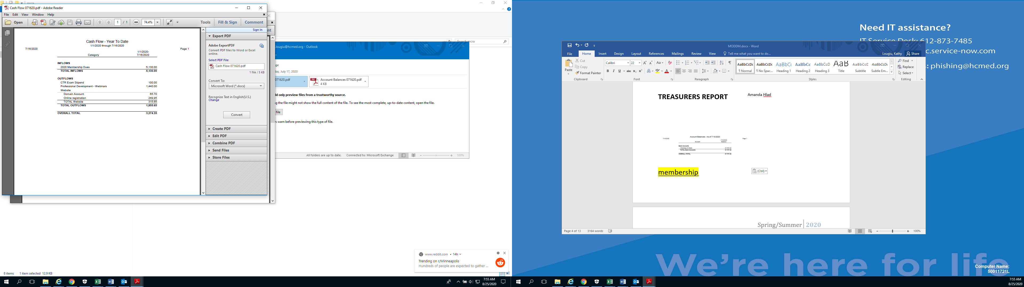

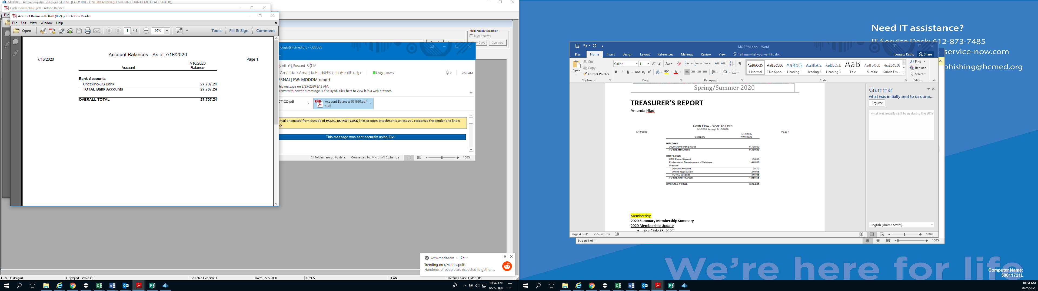

**MEMBERSHIP**

Submitted by Chunny Daiker

**2020 Summary Membership Summary**

**2020 Membership Update**

* As of July 16, 2020
  + There is a total of 116 members
* 14 new members
* 2 honorary members

MCRA welcomes any person to join year-r

ound!

Thank You for your support for MCRA!

**WEBSITE**

Submitted by Tom Coles

The website has been updated with a new template for a modernized look and feel.  The photo on the website was taken by the Website Guy up in the BWCAW in Minnesota, where he is known as Nature Guy.  The website continues to be updated with the NAACCR webinars as they are released for viewing.

The username is **registry** and the password is y20MCRA20*

**PROFESSIONAL DEVELOPMENT**

Candace Scherping, Heidi Leach, Melanie Nelson, LaurelLyytinen 

The WCRA/MCRA Regional Conference is coming! Conference is set for October 15-16, 2020. The event is being sponsored by RegAssist. The conference is free but you MUST register by October 2. Then link to register is: <https://ti.to/wcra/wcramcra-5th-annual-regional-education-conference/with/conference-registration>. The link for the brochure and agenda can be seen here: <https://wicancerregistrarsassoc.com/wp-content/uploads/2020/07/2020-WCRA-MCRA-Annual-Conference-Brochure.pdf>

Another great educational opportunity is NCRA Annual Conference in the fall. The registration cut-off for this is September 10, 2020 with the opportunity to earn as many as 24.5 CEU’s! This event is going fully virtually. The fee for the full conference is $200 for members.

**COMMUNICATIONS**



Submitted by Kathy Lougiu

April 6, 2020 CP3R updates from the 2019 Call for Data which included diagnosis year 2017 was released to the public. After the initial release NCDB realized they were reporting the V18 radiation data items incorrectly. Therefore, NCDB reverted all submitted v18 radiation data items back to what was initially sent to us during the 2019 Call for Data and only applied the v16 NAACR conversion radiation data items and released CP3R on 7/29/2019. CP3R was again released on 8/19/2020. Please review your program’s CP3R and let NCDB know of any concerns.

**AJCC Moving from Editions to Versions in 2021**

The American Joint Committee on Cancer (AJCC) is making an important change to how it updates and releases Cancer Staging content beginning in 2021. The AJCC will be shifting from a *Cancer Staging Manual* to a *Cancer Staging System* and moving away from *Editions*, to *Versions* which better align with software development and how users are increasingly consuming AJCC content. Version 9 of the Cervix Uteri Cancer Staging System will go into effect January 1, 2021.



**CODING CORNER –**

Submitted by Carol Forbes-Manske

**CODING NEWS:**

**High-Grade Serous Carcinoma of Ovary, Fallopian Tube & Peritoneum/Retroperitoneum** – new code 8461/3. This applies to codes C48._, C56.9, C57.0, C57.1-C57.3.

**Low-Grade Serous Carcinoma of Ovary, Fallopian Tube & Peritoneum/Retroperitoneum** – new code 8460/3. This applies to codes C48._, C56.9, C57.0, C57.1-C57.3.

Please refer to the 2018+ ICD-O-3 Coding Table and code accordingly. DO NOT assign 8441/3 (serous ca, NOS) out of habit.

**REMINDER: HPV AND P16 –** HPV and p16 are used differently; p16 is used for staging and HPV viral test results are used to code histology of 8085 or 8086. NAACCR Base of Tongue webinar explained this well.

**HEAD & NECK – Coding Squamous Cell Carcinoma, HPV-negative and HPV-positive** – MCRS has noticed registrars coding 8086 (HPV mediated negative) and 8085 (HPV mediated positive) oral cancers based on IHC p16 positive or negative results. IHC should not be used to determine HPV mediated codes. **HPV and p16 are used differently; p16 is used for staging and HPV viral test results are used to code histology of 8085 or 8086.**

Per the Solid Tumor Rules (STR): Squamous cell carcinoma HPV-negative 8086, and Squamous cell carcinoma HPV-positive 8085.

* ***Note:*** HPV-positive is not equivalent to HPV-mediated (p16+). According to the 2018 SEER Manual, HPV-type 16 refers to virus type and is different from p16 overexpression (p16+). HPV status is determined by tests designed to detect **viral DNA or RNA**. Tests based on ISH, PCR, RT-PCR technologies detect the viral DNA or RNA; whereas, the test for p16 expression, a surrogate marker for HPV, is IHC. **HPV testing must be positive by viral detection tests in order to code histology as 8085.**

Registry supervisors may want to audit these cases to determine if the appropriate HPV mediated positive or negative has been coded with supporting text.

**PRIORITY ORDER FOR IDENTIFYING PRIMARY SITE WHEN THERE IS CONFLICTING INFORMATION, HEAD & NECK** – With head and neck cancers pay close attention to the priority order given in the STR Manual, i.e. Tumor Board comes before tissue/pathology from tumor resection or biopsy. Review the STR Manual for priority order, use of Tables to aid in assigning primary site, etc. View/review the NAACCR Base of Tongue webinar for additional information.

**LUNG HISTOLOGY QUESTION**  - What histology code should be assigned for a lung primary, one tumor, resection final diagnosis is invasive mucinous adenocarcinoma, acinar predominant; CAP Histologic Type is adenocarcinoma, acinar predominant; and Microscopic states tumor consists of predominately acinar architecture with a minor lepidic component? There were differing opinions among registrars to code 8551/3 – mucinous, acinar predominent, per H1, Note 1, and 8255/3 – adenocarcinoma with mixed subtypes, per table 2, combination of codes not listed on previous rows of this table. This question was sent to Ask a SEER Registrar. Their answer, Ask SEER CTR #2369: Lung rule H1 applies: code the histology to 8551/3. See Lung H rules, "Coding Histology" section, #1, Note 1. It states that you may code a histology identified as a component when that component specifically describes a carcinoma or sarcoma. Lepidic component is not synonymous with lepidic carcinoma/adenocarcinoma. Ignore the lepidic component and code to 8551/3. Do not use the microscopic portion of the report to code histology.

**CASEFINDING LISTS** – Registries may use the SEER Casefinding Lists by selected year to screen prospective cases and identify cancer cases for inclusion in the registry. The FY2020 ICD-10-CM Casefinding List and other years can be found on the SEER website <https://seer.cancer.gov/tools/casefinding/> in PDF or Excel format by year. Hospital IT departments should be able to develop a query to compare the casefinding list against the facilities billed ICD-10-CM codes.

**2021 CHANGES TO GRADE** – there are minor updates to grade data for 2021. Instructions for the new grade data item Grade Post Therapy Clinical (YC) will be coming.

**INFORMATION FROM 2019 SEER ADVANCED TRAINING WORKSHOP:**

**SOLID TUMOR RULES** **–**

**Lung** –

1. Obsolete terms and codes **can** be used **when they are the only information/ diagnosis available.**
2. Code the most specific histology, whether from a biopsy or resection specimen. (Do not use this rule for Breast.)
3. Use 8255 (mixed adenocarcinoma) only as a last resort. WHO Lung editors excluded 8255 but the “real world” still used it.
4. Code histology prior to any neoadjuvant treatment.
5. Non-small cell lung cancer (8046) – **do not change the histology code in order to AJCC stage.** **Only Summary Stage can be assigned these lung cases.**

**Breast** –

1. Duct & Lobular carcinoma – DO NOT use 8522 when the diagnosis is carcinoma, NST/duct carcinoma with lobular differentiation, or carcinoma, NST/duct carcinoma with lobular features. Invasive carcinoma with duct & lobular features (mixed type carcinoma) is the term used for ductal mixed with lobular (8522).
2. Chest wall metastasis/recurrence/new primary? If the path states tumor originated in residual breast tissue = new primary; if path states tumor arose in chest wall, or, there is no designation of residual breast tissue = recurrence. Hormone receptors are not used to determine multiple primaries.
3. There is a “90%” rule in the breast histology. Become familiar with the breast rules as they are very different from other sites.

**Urinary** –

1. Micropapillary urothelial carcinoma is uncommon but at high risk for metastases. It is more aggressive than urothelial carcinoma so rules had to be changed. Rule H5 – code 8131/3 for micropapillary urothelial carcinoma.
2. Adenocarcinoma and squamous cell carcinoma of urinary sites are to be coded only if **pure** (not mixed with any other histology).

**Possible Upcoming Changes to Solid Tumor Rules –**

1. Cutaneous Melanoma will be adding “H” rules for mixed melanomas.
   1. Melanoma of left stomach and melanoma of L back = single primary. If these were made 2 primaries melanomas would be over counted.
   2. There is a possibility of resurrecting the multiplicity counter.
2. Other Sites Rules – anticipate adding more site-specific modules, i.e. GYN, Male Genital, Other GI, Esophagus, Liver, Pancreas, Bile Ducts.
3. Urinary Timing Rule –
   1. If a patient has a ureter cancer in 2018 and in 3 years has another urinary primary it is not a new primary.
   2. If a patient has a bladder cancer and a year later renal pelvis cancer, same histology, it is a single primary.

**MCRS Update –**

**New Section Manager/Program Director** – Jay Desai has been appointed Section Manager/Program Director of MCRS. Jay has been working in chronic disease epidemiology since 1990 with an emphasis in physical activity, healthy eating, tobacco use, obesity, diabetes, cardiovascular disease, chronic kidney disease, gout, and cancer prevention. He also has a strong interest in implementation science and health equity. For the last 9 years, Jay was a research investigator at the HealthPartners Institute (HPI) studying primary care clinical decision support, using EMR's for national diabetes and obesity surveillance, diabetes prevention in low income individuals, and HPV vaccination in underserved communities. Prior to HPI, Jay spent 16 years as the epidemiologist for the Minnesota Diabetes Program at MDH. He is excited to be back with MDH and the challenge of learning about and growing the Minnesota Cancer Reporting System.

**The majority of MCRS staff have been reassigned to COVID-19 response.** Emails or questions to staff may be delayed due to reassignments.

 Meet the 2020 MCRA Executive Committee

**President - Jess Klaphake**, RHIT, CTR – *President-Elect:* St. Cloud Hospital/Coborn Cancer Center, St. Cloud. Member since 2014.

**President Elect – Jackie Halsey,** CNMT, CTR, Rochester Communtity & Technical Colleger, Rochester. Member since 2010

**Past President, Jen Nelson**, CTR, NR-EMT –past *President:* MN Cancer Surveillance System, St. Paul. Member since 2011.

**Kathy Lougiu,** CTR – *Communications & MODMM:* Hennepin Healthcare. Member since 2014.

**Linda Vanstrom**, RHIT, CTR – *By-laws:* Minneapolis VA Health Care System, Minneapolis. Member since 1994.

**Amanda Hlad**, RHIA, CTR – *Treasurer:* St. Joseph’s Medical Center, Brainerd. Member since 2007.

**Julie Heyd,** CTR– *Secretary:* Rochester Community & Technical College, Rochester. Member since 2010.

**Carol Forbes-Manske**, CTR – *MCSS Liaison:* MCSS, St. Paul. Member since 1986.

**Chunny Daiker**, BS, RHIT, CTR – *Membership:* Hennepin County Medical Center, Minneapolis. Member since 2009.

**Tom Coles**, CTR, CHES – *Website:* Allina-Abbott Northwestern Hospital, Minneapolis. Member since 2009.

**Erin Hammell (Chair), Jen Nelson, Nancy Hedstrom, LeeAnn Olson** – *Nominating Committee*

**Jackie Halsey, Cindy Sanborn, Jess Klaphake**– “Laurie Griffin *Outstanding Member” Award Committee*

**Candace Scherping**, **Heidi Leach, Melanie Nelson, Laurel Lyytinen**– *Professional Development*