Minnesota Cancer Registrars Association

THE MODMM

The Minnesota Oncology Data Managers Monitor

PRESIDENTS MESSAGE

William Arthur Ward once wrote, “Gratitude can transform common days into thanksgivings, turn routine jobs into joy and change ordinary opportunities into blessings.” I hope you don’t have to look very hard to find things in your life to be grateful for. For me, there’s nothing more important than appreciating what’s right in front of you and sharing your wealth – whether it’s tangible or abstract, like your talents and time, for others.
From my perspective, your attitude can greatly affect what you put out there in the world. Coming from a large family of eight kids and having our mother widowed at 30, we learned at an early age what’s really important in life – each other. You don’t have to come from a big family to feel connected with others. I’m sure if you look no further than your own back yard you’ll find people in your community needing an open ear or an extended hand. None of us are an island and we all have something to give. We all bring something unique to the table and sharing our strengths with each other is what makes this world so grand.

Our recent regional registry workshop in October was a great example of a team of people and talents working together for the common good. Not only was it fun to be a part of, but a joy to watch unfold. For those that weren’t able to attend, we had a great mixture of speakers and topics with special attention to AJCC 8th Edition changes. In an attempt to help you plan for your educational needs in the future, the executive committee has committed to work with WCRA for the next two years to jointly offer regional workshops. Then after that timeframe, we will reassess with our members to see what our needs are at that time.

We welcome you to join us in Wausau next October 11-12th for the 3rd Regional Registry Conference with our Wisconsin friends, and then another regional meeting in MN for 2019. With all the changes in the registry field with 8th Edition AJCC Staging and new multiple primary rules, we hope to continue to provide our members with the best national speakers we can attract. Realizing that not all facilities can send all their registrars to regional meetings every year, we’re thrilled that HCMC in Minneapolis has offered to host a local workshop on Friday, April 20th. These workshops along with the MCRA sponsored NAACCR webinars will hopefully give you, our members, ample education to keep up with the changing times in the cancer registry world.

As we all prepare to navigate the holidays and yet another Minnesota winter, may we remember that simple gifts of time are priceless. Time spent playing a game together or conversations unraveled in the kitchen can be so meaningful. If you’re looking for a fun group experience, try one of the popular escape rooms. I’ve done the Inheritance Room at the Mission Manor escape rooms in Minneapolis and it was very cool! I’d highly recommend it. A friend did a prison escape room at the Mall of America, and said that was very good as well. They’re a fun way to work together as a team to problem solve and ultimately, help each other escape the room! Hopefully, there’s plenty of fun intermixed with all the sleuthing. If anyone is interested in trying an escape room out, but needs some willing participants to share the journey with them, let me know and I’ll try to coordinate an outing.


Whether you get the opportunity to escape a room or part of the winter, here’s hoping that your time is well spent. And when you reflect, may you find that indeed you have much to be grateful for. I’m grateful for having had this time to connect with all of you. Until next time, and as always, sending warm thoughts your way. Merci!

Most sincerely,
Janice Anastasi, CTR (MCRA President)

Nominating Committee
Submitted by Kim Gums

We would like to thank all the members who volunteered to remain in their current roles on the executive committee for another year along with the new volunteers for 2018.

The following members have graciously offered to step into the open positions:

Website Coordinator - Tom Coles
President-Elect – Jen Nelson

Currently all roles are filled for 2018; however, we can always use additional volunteers to assist on the executive board committees.

Thanks,
Kim & Carol

MCSS REPORT
Carol Forbes-Manske

Reminders when abstracting cases:
- Address at diagnosis – be aware of patients’ home state when abstracting. Snowbirds may actually be MN residents even if diagnosed out of state, others may be non-MN residents at diagnosis. Medical oncologist consults may be a good place to find state of residency.
- Social security numbers – be careful to accurately determine and enter the social security number.
- Beware of typos – typos on sex and laterality are not uncommon. Please check your data entry when abstracting a case.

MCSS staff are working on abstracting and consolidating 2015 data. You may receive calls from staff requesting clarification on cases.

Upcoming Excitement –
- AJCC 8th Edition Chapter Updates to Histologies will be forthcoming. Check the AJCC website for updates.
- New and Revised Site Specific Data Items (SSDIs) – SSDI codes and coding instructions will be on the NAACCR website 3/15/18. SSDI Manual will be released 4/1/18.
- ICD-O-3 Histology Revisions Update – guideline and codes will be released 12/1/17 with site/histology validation list and excel file to be released mid-December, 2017.
- Solid Tumor Rules (previously called the Multiple Primary and Histology Coding Rules) – the committee has completed the review of 5 site groups (Head and Neck, Colon, Lung, Breast, and Benign Brain); the remaining 3 site groups should be completed by 11/1/17 (kidney, Ureter/Renal Pelvis/Bladder and Malignant Brain). The final version of the new manual is to be released 1/1/2018. Melanoma and “Other Sites” groups could not be updated because the corresponding WHO Classification 4th edition had not been published yet.
- SEER Summary Stage 2018 should be released by 12/22/17.

Bylaws
Linda Vanstrom

Bylaws can be found on the MCRA website: click on the “Documents” tab, then the hyperlink for “MCRA Bylaws”.

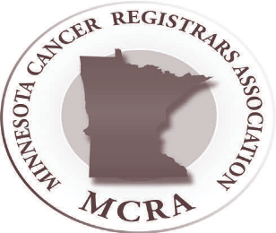

TREASURERS REPORT
Amanda Hlad

The current balance in the MCRA bank account is $16,267.31. The income and expenses for the year to date currently results in a surplus of $7,293.15. There are no further expenses that are expected for the remainder of the year. I have also included a summary of the income and expenses for the Regional Conference. That resulted in a surplus of $4,631.81 for MCRA. (The April Fritz Raffle income was $184.00 – not included in report since it’s not income for MCRA.) Please contact me with any questions that you that about the reports.

*******************************************************
Regional Conference Cash Flow
Inflows
2017 Regional Conference Income
Registration $22,753.22
Silent Auction $506.00
Vendor $5,675.00
TOTAL 2017 Regional Conf Income $28,934.22
TOTAL INFLOWS $28,934.22

Outflows
2017 Regional Conference Expenses $75.00
Food $11,604.00
Meeting Space $7,755.96
Pre-Paid breakfast $54.00
Speakers $1,903.18
Supplies $381.56
WCRA Profit $2,528.71
TOTAL 2017 Regional Conf Expenses $24,302.41
TOTAL OUTFLOWS $24,302.41
OVERALL TOTAL $4,631.81
MCRA Cash Flow (1/01/2017 through 11/18/2017)
INFLOWS
2016 MCRA/WCRA Regional WS $827.06
Uncategorized $105.00
2017 Membership Dues $4,993.83
2017 Regional Conference Income
April Fritz Raffle $184.00
Registration $22,753.22
Silent Auction $506.00
Vendor $5,675.00
TOTAL 2017 Regional Conf Income $29,118.22
2017 Spring Workshop Registration $2,411.83
NCRA Basket Income $82.92
TOTAL INFLOWS $37,538.86

OUTFLOWS
2017 Regional Conf expenses $75.00
Food $11,604.00
Meeting Space $7,755.96
Pre-paid Breakfast $54.00
Speakers $1,903.18
Supplies $381.56
WCRA profit $2,528.71
TOTAL 2017 Reg Conf Expenses $24,302.41
2017 Spring Workshop $876.51
Bank Charge $30.00
CTR Exam Stipend $300.00
Executive Committee
Envelopes, labels, postage $6.65
Gift $30.00
TOTAL Executive Committee $36.65
NCRA Meeting
MCRA – President Elect Support $2,290.79
TOTAL NCRA Meeting $2,290.79
Professional Development-Webinars $1,440.00
Website
Domain Account $119.40
Online Registration $849.95
TOTAL Website $969.35
TOTAL OUTFLOWS $30,245.71

OVERALL TOTAL $7,293.15

We Are Professionals Who
Manage data describing the diagnosis and treatment of cancer. Promote quality cancer data collection and cancer program management.

Website
Holly Zabinski

Beginning February 1, 2018, the website coordinator position will transfer from Holly to Tom Coles. Thank you, Tom for offering to take this over! And huge thanks to Holly for all your work with the website to keep it as updated as possible.

The website continues to be updated with NAACCR webinars as they are released for viewing. If you have any questions about the webinars or if you are having technical difficulties with the webinars, there is NAACCR contact information at the end of every webinar instruction document. Please contact NAACCR for those questions as I don’t have any ability to remedy issues with the webinars outside of entering the information on the website.

The username is registry and the password is CancerMN17!

PROFESSIONAL DEVELOPMENT
Heidi Leach, Candace Schoolmeesters, Jen Nelson

Spring 2018 MCRA Conference and business meeting to be held at HCMC Whitter Clinic on April 20th, 2018.

Plans are underway for the next Regional Conference with WCRA to be held in Wausau, Wisconsin on October 11th – 12th, 2018! More information and registration details will be e-mailed out to members!

Reminder: NAACCR webinars are available on the MCRA website approximately 1 week after the live presentation. Take some time to view past presentations.

Another free opportunity for education is through SEER Educate – check it out at educate.FredHutch.org.



Congratulations to Bayli Rettig on recently passing the CTR Exam!!!
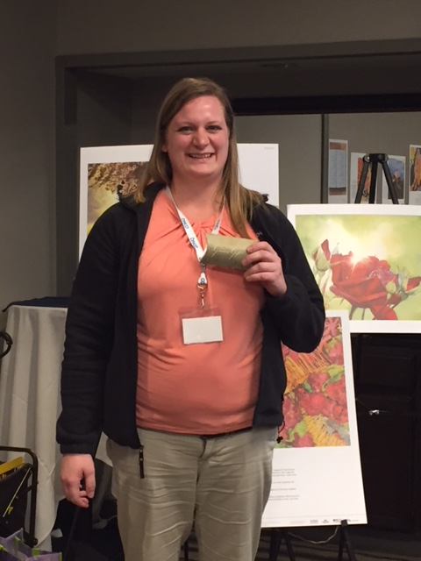

NCRA has not announced the CTR Examination dates for 2018!
The 2018 Handbook/Application for Candidates and Exam Dates are coming soon! If you are looking for this information please contact ctrexam@ncra-usa.org to request a copy of the free handbook and dates.
For additional information, go to www.ctrexam.org

Communications
Jess Klaphake

AJCC 8th Edition – errata is updated on their website. If you want to be added to their mailing list or just to check it out, go to www.cancerstaging.org/references-tools/deskreferences/pages/default.aspx
Along with the errata, the AJCC decided to validate and update the 8th Edition Breast Cancer Staging System. The new, updated chapter can also be downloaded to your computers using the above same website.

There are a few documents pertinent to members on the MCRA Website – click on the “Documents” tab – here you can find MCRA Bylaws, the Policies and Procedures Manual and MCRA Job Descriptions.

I recently read a beautiful tribute to April Fritz in the Fall 2017 edition of “The Connection”. Karen Phillips, BS, CTR; Gayle Clutter, RT, CTR; and Annette Hurlbut, RHIT, CTR, share stories of April and remember her important contributions to the cancer registry profession. If you didn’t get to see it, you can read the article at:
http://www.ncra-usa.org/Portals/68/PDFs/Final%20Fall%202017%20Connection.pdf?ver=2017-11-07-095743-797

Membership
Chunny Daiker

2017 Membership Summary
Membership Numbers
- As of October, there is 117 members.
  - 17 new members
  - 6 honorary members

3rd and final revision of 2017 MCRA Directory emailed out in October
- The following changes/updates made:
  - A page recognizing and listing all MCRA members who have been awarded the “Laurie Griffin Outstanding Member” award.
  - 1 new member

Membership 2018
- 2018 Membership Forms and Fees will be Due Feb 1, 2018.
- Email reminders for membership renewals will be sent beginning January 1, 2018

Membership continues to be open year ‘round and members can join the association anytime!

2nd Annual MCRA/WCRA Regional Conference 2017

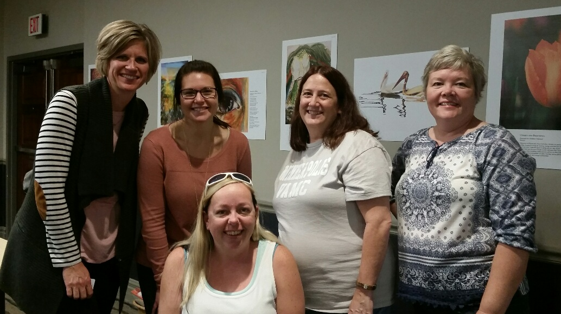
The 2nd regional conference with WCRA was held on October 12th-13th in Bloomington. We (on the planning committee), were elated to learn that attendance was significantly higher than we had anticipated and although the conference room seemed too overly cozy with other members, we were able to accommodate everyone who wanted to attend.

Day one was our National speaker, Denise Harrison, who provided an entertaining jump start on educating us about the AJCC 8th Edition Staging Manual. The main sites she covered were breast, prostate, and lung. Her presentation was a great eye opener to some of the changes to come. Remember we are all in this together!

Day two was filled with a variety of topics, some in which we as registrars don’t often think about but are equally important in treating patients. Such as palliative and hospice care and naturopathic modalities combined with standard treatment protocol. Dr. Leach had a very informative presentation on covering genetic mutation testing for lung cancer and the different treatment that can be used in conjunction with those who carry these mutations. Other presentations included GIST and why a pathologist cannot always say if these are benign or malignant and geocoding.
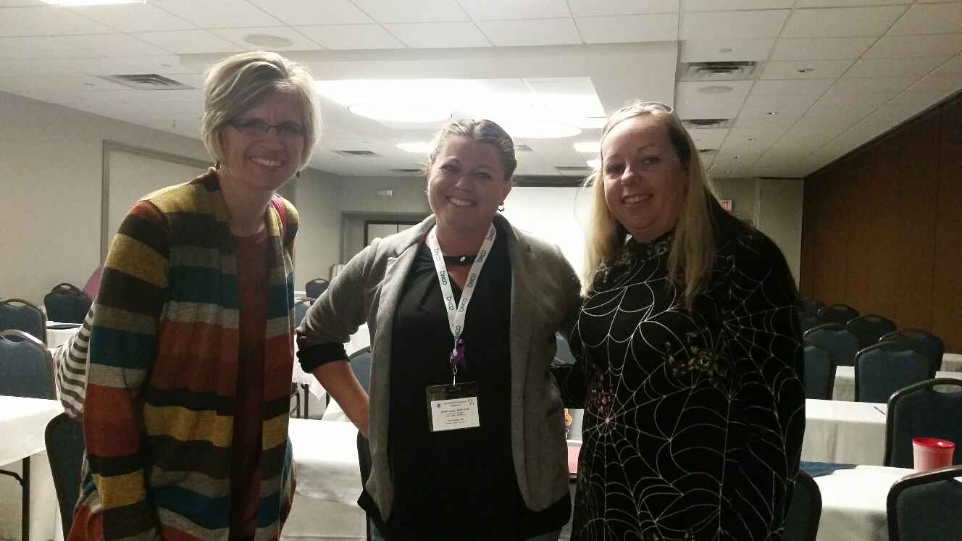
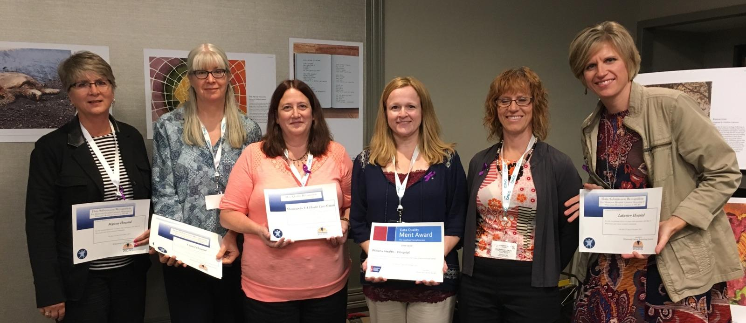
While we were given a wealth of information in just 2 short days, we were able to also have a little fun. Check out the following pictures submitted by attendees of the conference. Enjoy!
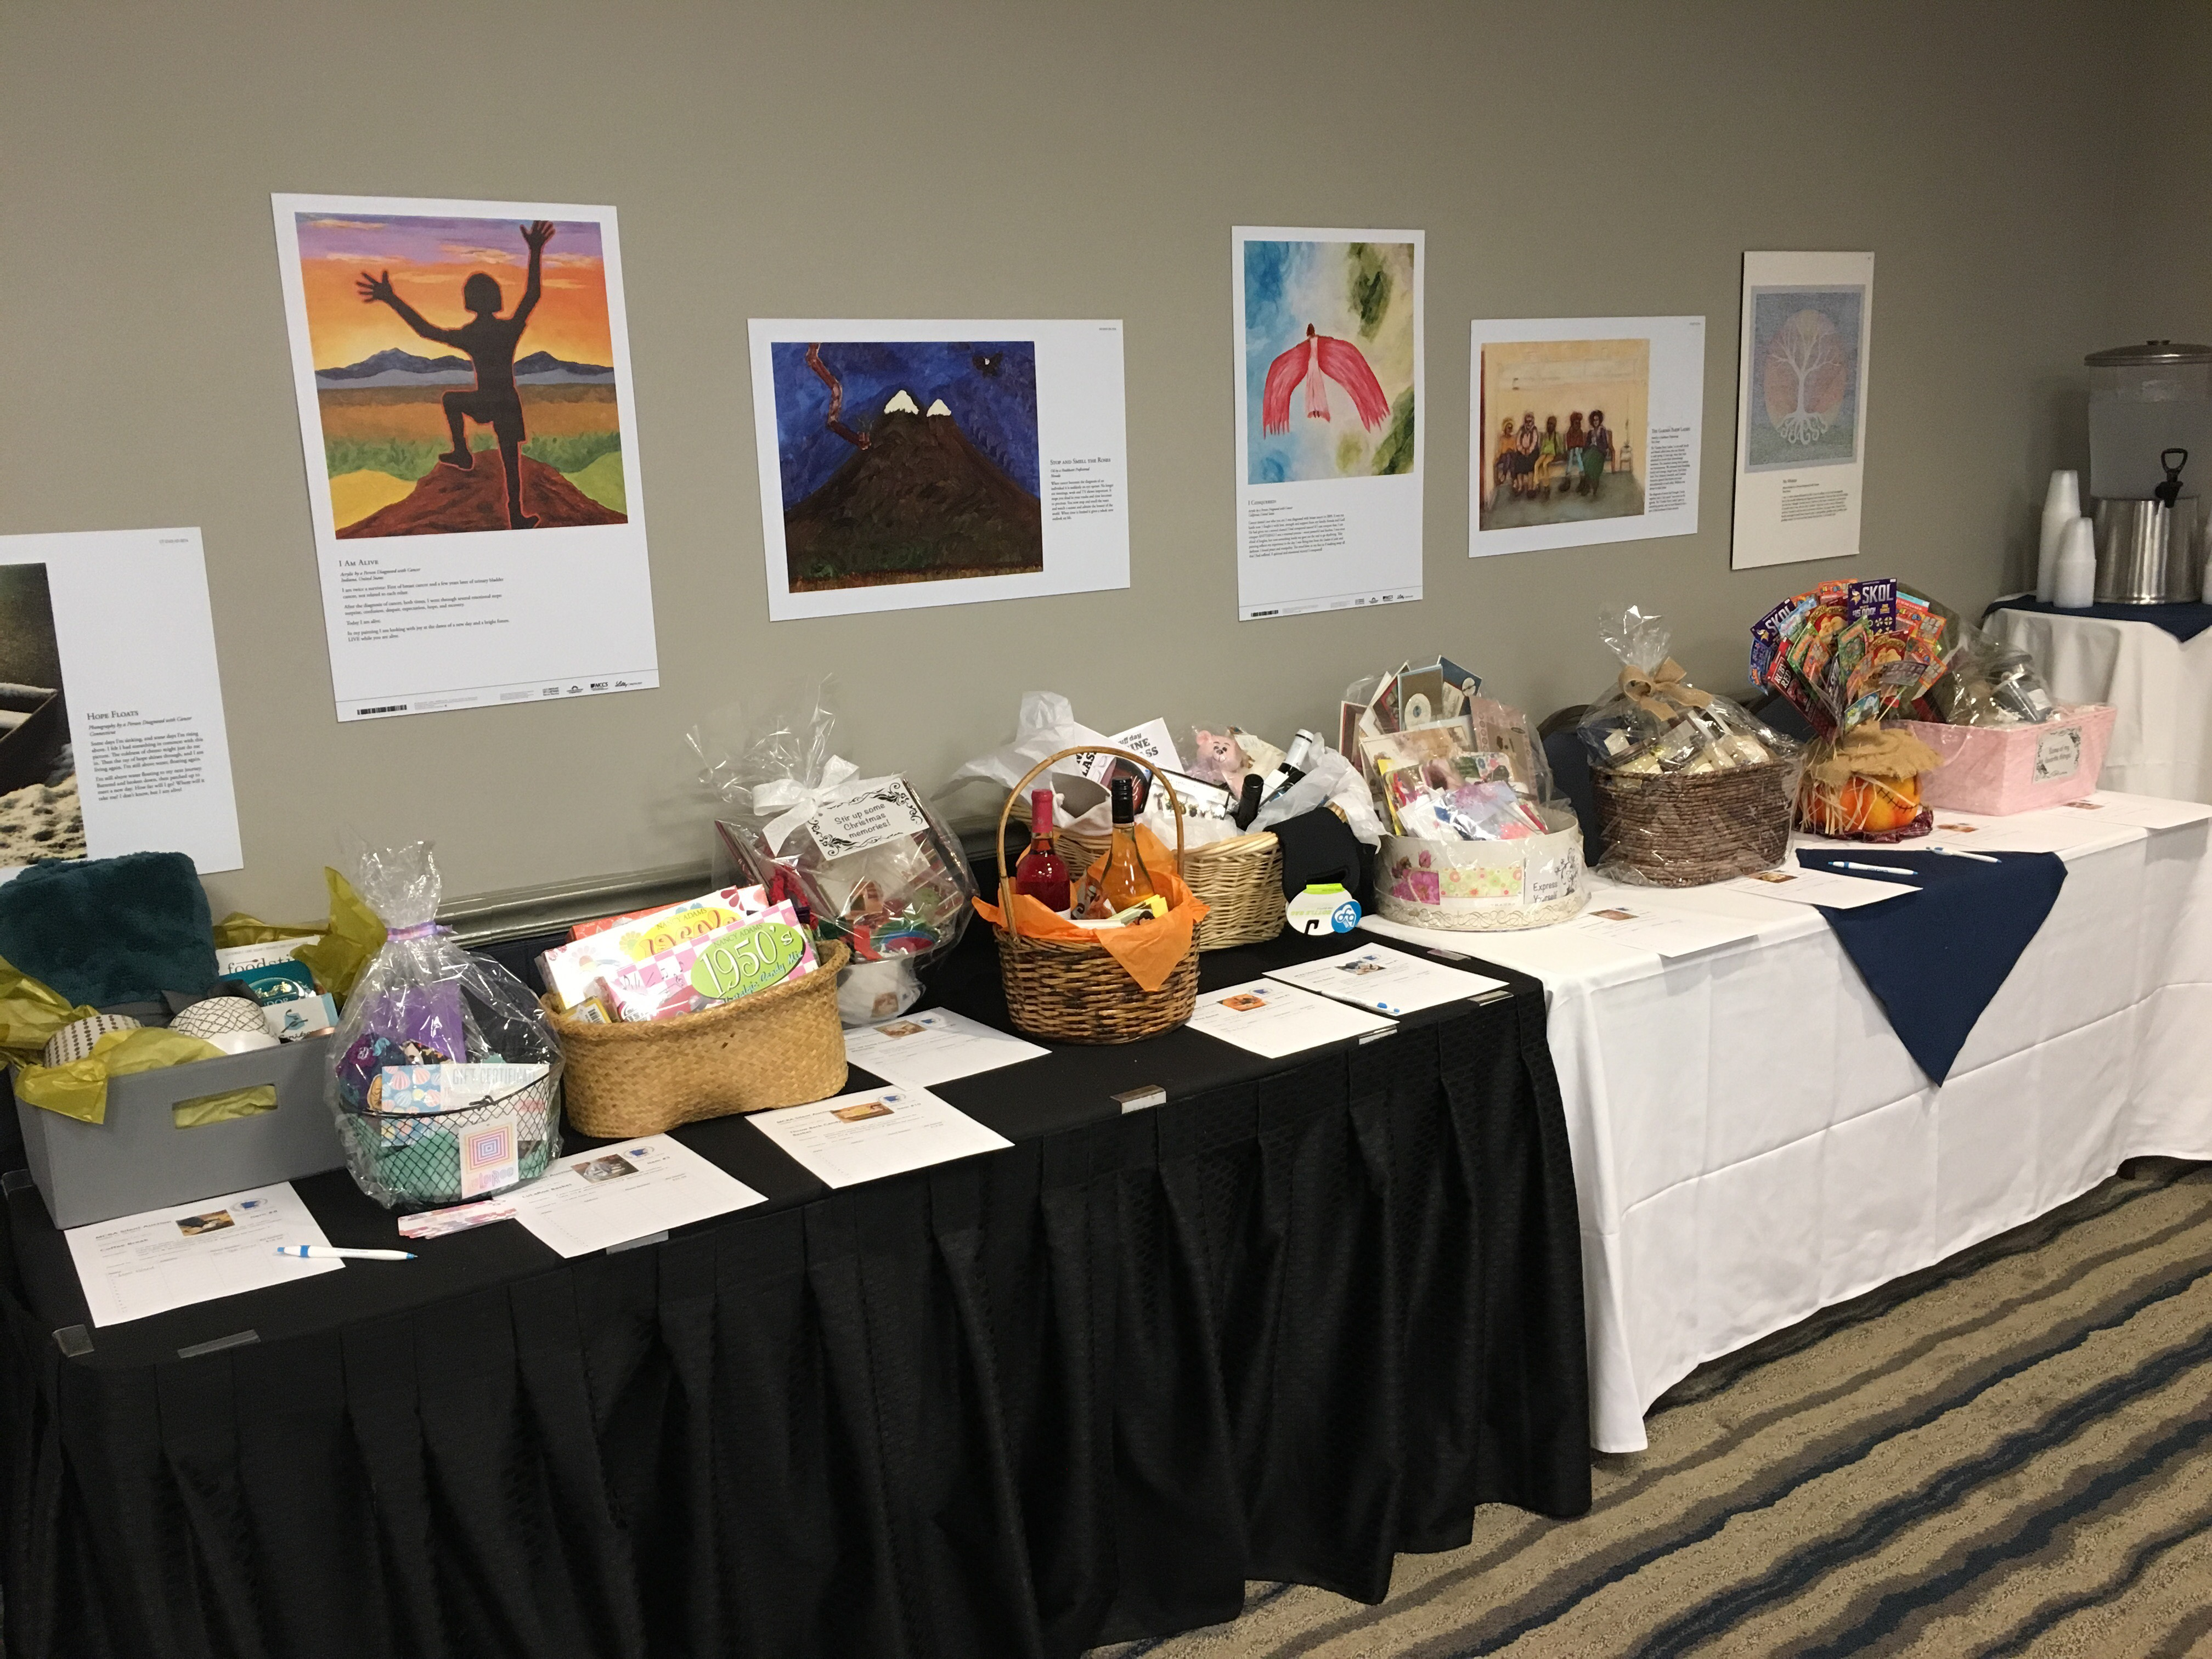

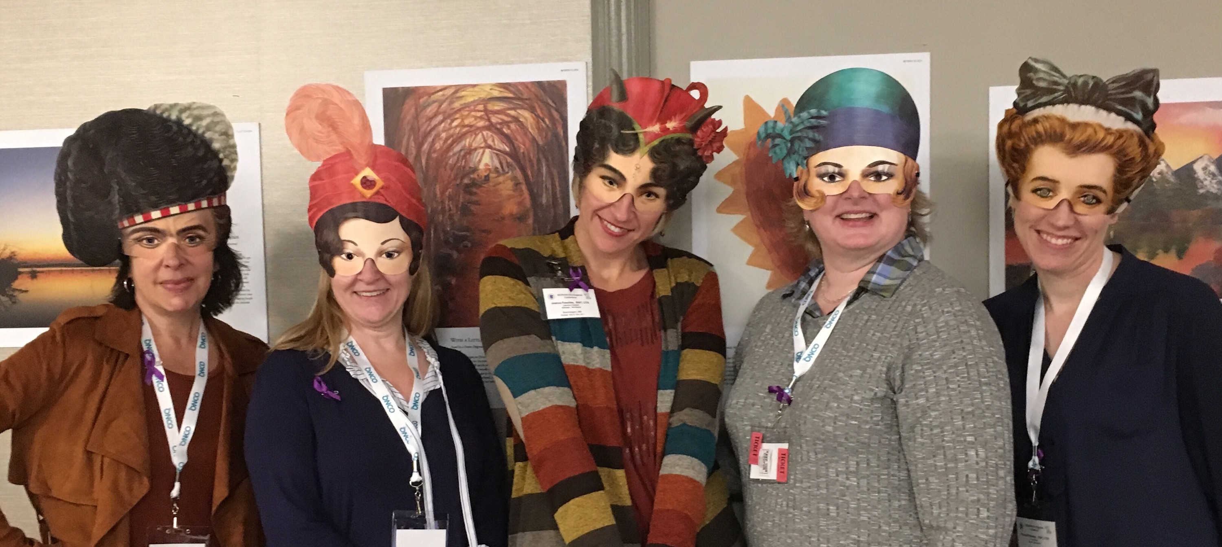

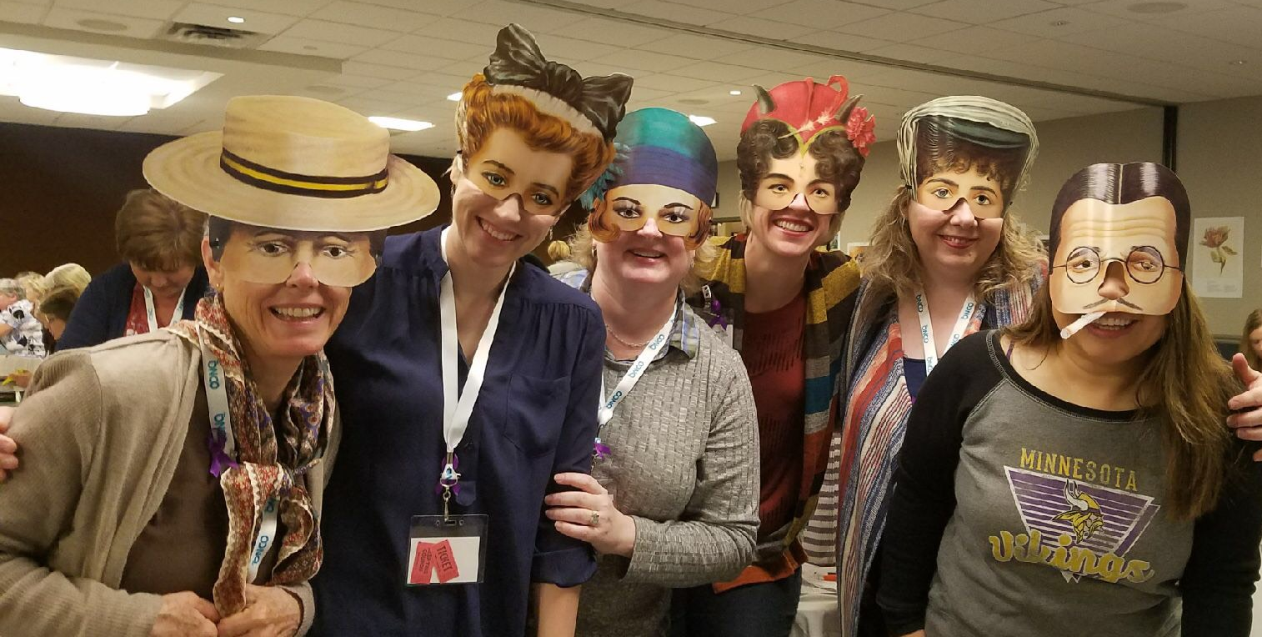
A few thank you’s:
Thank you to all who were able to attend and help make this a great conference.
Thank you to those who donated a silent auction basket and to the raffle.
Lastly a special thanks to the planning committee. The amount of time and effort you put into providing a great first regional conference in Minnesota did not go unnoticed. You all are rock stars!
Meet the 2017 MCRA Executive Committee

Janice Anastasi, CTR - President: St. Francis Regional Medical Center, Shakopee. Member since 1989.

LeeAnn Olson, CTR – President Elect: MN Cancer Surveillance System, St. Paul. Member since 1996.

Chris Bushaw, Med, RHIT, CTR – Secretary: Rochester Community & Technical College, Rochester. Member since 2016.

Amanda Hlad, RHIA, CTR – Treasurer: St. Joseph’s Medical Center, Brainerd. Member since 2007.

Linda Vanstrom, RHIT, CTR – By-laws: Minneapolis VA Health Care System, Minneapolis.

Jess Klaphake, RHIT, CTR – Communications & MODMM: St. Cloud Hospital/Coborn Cancer Center, St. Cloud. Member since 2014.

Chunny Daiker, BS, RHIT, CTR – Membership: Hennepin County Medical Center, Minneapolis. Member since 2009.

Candace Schoolmeesters, Heidi Leach, Jen Nelson – Professional Development

Holly Zabinski, RHIT – Website: St. Cloud VA Medical Center, St. Cloud. Member since 2006.

Kimberly Gums, Carol Forbes-Manske, Trista Leong – Nominating Committee

Carol Forbes-Manske, CTR – MCSS Liaison: MCSS, St. Paul. Member since 1986.

Jackie Halsey, Cindy Sanborn, Trista Leong, Kathy Lougiu – “Laurie Griffin Outstanding Member” Award Committee

