Minnesota Cancer Registrars Association

## THE MODMM

## The Minnesota Oncology Data Managers Monitor

**PRESIDENTS MESSAGE**

**President’s Message**

NCRA’s 45th Annual Educational Conference was held in Denver, Colorado, May 20-22, 2019. Opening day started with Dr. Ted Williamson discussing the Evolution of Cancer and Cancer Care. Dr. Williamson discussed the “War on Cancer” Strategy from 1971. He walked us through the changes in chemotherapy, surgery and radiation, from the 1970’s to today, stating “Even now, with all the chemical and technological advances of the last 48 years, our best opportunity for reducing the cancer burden is with prevention”. Dr. Williamson highly recommended reading *The Emperor of All Maladies, a Biography of Cancer* by Siddhartha Mukherjee.

Monday was full of discussions regarding precision medicine, genetic testing and counseling, the use of natural language processing and coding genetics via SSDI. Day two, Tuesday, focused on updates from the College of American Pathologists, National Cancer Database and North American Association of Central Cancer Registries. Jim Hofferkamp discussed working with edits, Wilson Apollo presented radiation treatment using the STORE Manual and Donna Gress talked about navigating the AJCC 8th Edition Staging Manual.

Tuesday I attended the Presidents’ Luncheon where each president was asked to discuss successes and struggles of their associations. Many state presidents stated they could not get anyone to volunteer for positions within their association, even with paying for the president to attend NCRA’s annual meeting, so some presidents have served from three to six years before a new leader stepped into the role. In this regard, I feel we are very fortunate to have the volunteers we do and want to take this opportunity to thank members who are currently working on planning another great regional meeting with Wisconsin!

Speaking of the regional meeting, a very hot topic at the President’s Luncheon was the suggested revision to the CoC Standard regarding removing commendation for registry staff to attend a regional or national meeting. Many members expressed frustration with the lack of support to attend these educational meetings before this possible revision, knowing moving forward they will no longer be allowed to attend if it is not a requirement, or if they want to attend the expense will be out of their own pocket.

Day three of the conference was broken out into three different sessions; hospital, central and management professional development. I attended the hospital session with the day concentrating on gynecologic, head and neck, lung and melanoma.

It was three days of great information! I want to pass on that the presenters thanked us for the work we do and acknowledged what a large role our information plays in cancer care and research. Thank you to the association for the opportunity to attend this conference. It is always great to attend a national meeting to meet new people, hear them share the same frustrations, successes and we all share the passion to fight the war on cancer.

Sincerely,

Jennifer L. Nelson, CTR, NR-EMT (MCRA President)

**Nominating Committee**

Submitted by Nancy Hedstrom

We would like to thank those who volunteered to remain in their current roles on the executive board committee for another year, along with the new volunteers for 2019. At this time, all roles are currently filled for 2019.

In addition, we will be looking for volunteers and/or nominations in the fall to serve on the 2020/2021 term. We will be accepting volunteers and/or nominations of candidates until Monday, December 16th, 2019. *Please strongly consider volunteering so that we may keep our organization running smoothly.*

**These are the positions open for 2020/2021:**

**President-Elect:** Shall assume the duties of the President in his/her absence and shall succeed to the office of President at the conclusion of his/her term of office. The President-Elect shall co-chair the Professional Development committee. Ensure website information is correct.

**Secretary:** Shall be responsible for records of all MCRA proceedings and shall distribute minutes of all business meetings to the membership.

**Treasurer:** Shall be responsible for the receipt and disbursement of all funds of MCRA and shall make written reports to the Executive Committee and to the membership. The treasurer shall serve on the Membership Committee.

**These are the committees needing volunteers for 2020/2021:**

**Professional Development Committee:** Shall be Responsible for leadership in the Professional Development of MCRA membership. It shall include the President-Elect, with responsibility for educational programs. It will include persons responsible for support of members seeking CTR status, and any other members as deemed by the President or the Executive Committee.

**Communications Committee:** The Communications Committee will include persons responsiblefor the MCRA newsletter, the MODMM (The Minnesota Oncology Data Managers Monitor) and for taking photographs. Liaisons to the Minnesota Cancer Council, National Cancer Registrars association, Minnesota Health Information Management Association, Commission on Cancer, Minnesota Cancer Surveillance System, Others as felt necessary, in order to carry on the responsibilities of the communications committee.

**Website Coordinator:** Shall be responsible for working with the Webmaster to ensure smooth operation of the MCRA website.

**Nominating Committee:** There shall be at least four members on the Nominating Committee, the chairperson (appointed by the newly elected President), the immediate Past-President, and two other members elected by the MCRA at the April (Spring) Annual Meeting. They are responsible for preparing, mailing, and tallying the ballots in accord with Article V. No member of this committee shall be eligible for office.

**Membership Committee:** Shall be responsible for acceptance of new members and for distribution of updated rosters to the members. The MCRA Treasurer shall be a member of this committee and provide updated information on payment of dues.

**Eligibility:** Any member in good standing for one full year prior to nomination shall be eligible to hold office. To be eligible for the office of President-Elect, a member must have served one full term on the Executive Committee prior to nomination.

If more than 1-person volunteers and/or is nominated we will hold an election & ballots will be sent out.

Thank you for your consideration in fulfilling these positions,

Sincerely,

**Nominating Committee**

Nancy Hedstrom, RHIT, CTR

Carol Forbes-Manske, CTR

Erin Hammell, RHIT, CTR

LeeAnn Olson, CTR

**MCRS REPORT**

Carol Forbes-Manske, CTR

CODING NEWS FROM MCRS

Primary site for Waldenstrom’s macroglobulinemia (9761/3) changed to C42.1 (bone marrow) for cases diagnosed 2018+. (Primary site for cases diagnosed prior to 2018 is C42.0 (blood). Refer to the Hematopoietic & Lymphoid Neoplasm Database on line for more information.

Coding Scope of Regional Lymph Node Surgery when sentinel lymph node biopsy attempted but not performed. Refer to the 2018 STORE Manual, beginning on Page 248 –

Infrequently, a SLNBx is attempted and the patient fails to map (i.e. no sentinel lymph nodes are

identified by the dye and/or radio label injection) and no sentinel nodes are removed. Review the

operative report to confirm that an axillary incision was made and a node exploration was conducted. Patients undergoing SLNBx who fail to map will often undergo ALND. Code these cases as 2 if no ALND was performed, or 6 when ALND was performed during the same operative event. Enter the appropriate number of nodes examined and positive in the data items Regional Lymph Nodes Examined and Regional Lymph Nodes Positive.

MCRS has seen several edits relating to these two fields. Please review these items carefully when coding your cases. MCRS Thanks You.

**Bylaws**

Linda Vanstrom

Bylaws can be found on the MCRA website: click on the “Documents” tab, then the hyperlink for “MCRA Bylaws”.

## We Are Professionals Who

Manage data describing the diagnosis and treatment of cancer. Promote quality cancer data collection and cancer program management.

**TREASURERS REPORT**

Amanda Hlad

**INFLOWS**

2019 Membership Dues 4,711.91

**TOTAL INFLOWS 4,711.91**

**OUTFLOWS**

Laptop Computer & Printer 608.72

Website

Domain Account 29.85

Online registration 249.95

TOTAL Website 279.80

**TOTAL OUTFLOWS 888.52**

**OVERALL TOTAL 3,823.39**

**Website**

Tom Coles

The website continues to be updated with NAACCR webinars as they are released for viewing.

The username is **registry** and the password is 2019yMCRA*

**PROFESSIONAL DEVELOPMENT**

Heidi Leach, Candace Schoolmeesters, Jen Nelson



The WCRA/MCRA Regional Conference is coming! Conference is set for September 12th and 13th at Embassy Suites Airport!

With all of the new changes in 2018 here is a list of Important resources needed for 2018 coding.

* AJCC 8TH Edition, 3rd printing and errata – and KINDLE edition <https://cancerstaging.org/pages/default.aspx>
* STORE Manual <https://www.facs.org/~/media/files/quality%20programs/cancer/ncdb/store_manual_2018.ashx>
* SEER Summary Staging 2018 Manual <https://seer.cancer.gov/tools/ssm/>
* 2018 Solid Tumor Manual <https://seer.cancer.gov/tools/solidtumor/>
* ICD-O-3 2018 Revisions <https://www.naaccr.org/implementation-guidelines/#ICDO3>
* SEER Registrar Staging Assistant for EOD Extent of Disease 2018 Schema List V1.2. <https://staging.seer.cancer.gov/eod_public/home/1.2/> This provides valid values, definitions, and notes for:

o EOD Primary Tumor

o EOD Lymph Nodes

o EOD Mets

o SEER Summary Staging 2018

o SSDI’s including grade

* Site Specific Data items SSDI/Grade <https://apps.naaccr.org/ssdi/list/>

o SSDI Manual

o Appendix A and B

o Grade Manual

o Schema List

* NAACCR Standards and Data Dictionary <http://datadictionary.naaccr.org/>
* Grade Coding Instructions and Tables <https://www.naaccr.org/SSDI/Grade-Manual.pdf>
* SEER Rx Database <https://seer.cancer.gov/seertools/seerrx/>
* SEER EOD 2018 General Coding Rules Manual <https://seer.cancer.gov/tools/staging/2018-EOD-General-Instructions.pdf>

Reminder: NAACCR webinars are available on the MCRA website approximately 1 week after the live presentation.  Take some time to view past presentations.

**Next NCRA dates for the CTR Examination window is October 15 – November 3!**  
          The 2018 Handbook/Application for Candidates and Exam Dates are coming soon! If you are looking for this information please contact [ctrexam@ncra-usa.org](mailto:ctrexam@ncra-usa.org) to request a copy of the free handbook and dates. For additional information, go to [www.ctrexam.org](http://www.ctrexam.org/)

Communications

Kathy Lougiu

This is my first run at being the editor of the MODDMM. Please let me know what you would like to see in your newsletter! I would appreciate the feedback!





**2018 SEER Workshop**

Submitted by Carol Forbes-Manske

**SSDIs** – NAACCR website is the “official” site re: SSDIs, pdf manuals are on the NAACCR website. SEER*RSA has SSDIs listed also. “Grade” is considered an SSDI as it is site specific. The SSDI Manual has information regarding General Rules for Entering Lab Values & Other Measurements, General Definitions & Format of SSDI Codes, Schema Discriminators, SSDIs Required for Stage, SSDIs for specific sites.

**Grade** – Read the instructions for Solid Tumors in their entirety. There are now Letters and Numbers for grade coding. (Numeric pre-2018 grade codes have been changed to alpha codes for 2018+.) For example Breast, grades 1-3 are preferred for invasive cancer. L, M, & H are for in situ only. A-D are generic/historic grades such as well differentiated, moderately differentiated, etc. A-D are ONLY used if 1-3 or L, M, H are not documented. Grade “9” is used for heme/lymphoid except for one histology (follicular lymphomas) & one site (occular adnexal lymphoma). Blank is allowed for post-therapy grade.

Clinical grade cannot be blank. If one grade is given and it is unknown whether it is clinical or pathological, enter as clinical grade and code unknown (9) for pathological grade and leave post-therapy grade blank. (This would probably be used if patient diagnosed elsewhere and came to your facility for all or part of 1st course of treatment.)

Heme/Lymph Neoplasms – no longer coding grade EXCEPT:

1. Ocular adnexa lymphoma, chapter 71
2. Follicular lymphoma for 9690/3, 9691/3, 9695/3, 9698/3…

All other lymphomas would have clinical & pathological grade entered as “9” & post-therapy grade blank.

Questions from NAACCR Forum Shared:

Q1) How is grade coded with biopsy in 2017 & definitive surgery in 2018. Path report used 2018 CAP. A1) Code 2017 grade as patient diagnosed in 2017. Grade applies to year diagnosed, not year treated.

Q2) If no residual ca at time of definitive surgery, is pathological grade 9? A2) No – use grade the clinical grade.

Q3) Bladder TURP – most grades will be clinical grade for bladder cancers. If no resection, what grade do we assign? A3) Use “9” for pathological grade.

**Radiation Oncology Coding** – 24 new radiation data items for 2018, new “phase” specific (replaces modality & boost). There are rules defining when a phase begins. With 2018+ diagnoses & STORE, RT is documented in order of treatment given. If primary volume is LN, i.e. lymphoma “RT to Draining LNs” w/b 88. Code for 00 if diagnosed at autopsy. Code 08 – LN region, NOS, different code than primary - Code 09. Dose per fraction, Total dose (record what was actually delivered, not what’s planned), # of fractions (if patient had treatment in morning & again in the afternoon, that is 2 fractions, not 1). Questions/Answers –

Q1) Phase I applicable if RT to a mets? A1) Yes. If both primary & mets treated, record in separate phases (with primary entered in phase I). If only mets site, record in phase I.

Q2) Will total dose be auto-calculated? A2) Probably not, if you have 4 phases, you will need to add the dose from phase 4 even though it is not documented in RT (only 3 phases are recorded).

Q3) If you have RT to multiple metastatic sites with varied modalities & treatment volume, and possibly different end dates, how do you record this? A3) Record 3 phases in Phase I, II, & III & if you have 6 sites, record all radiation information in text.

**Solid Tumor Rules** – Continue to use previous MPH rules for sites not updated for 2018.

Revisions/Changes:

* Standardized similar rules throughout except for CNS, breast, skin & other
* Each revised site group now has specific priorities for coding
* Timing rules clarified, especially for urinary sites
* Timing rules differ by each site
  + One year or less = 365 days or less
  + More than 1 year = 366 days or more
    - Do NOT factor in if patient went on vacation, hunting, waited for treatment until crops planted/harvested
* Timing definitions of clinically disease-free
  + Snowbird, have date of diagnosis but unsure if clinically disease-free, default to date of diagnosis

Coding Histology 2018+

Priority –

1. Updated ICD-O Histologies & Terms Table <https://seer.cancer.gov/icd-o-3>
2. 2018 Solid Tumor Rules
3. ICD-O

How to Use Histo Rules –

* Do not use to determine reportability
* Single or Multiple tumor
  + H rules
  + Code histology prior to neoadjuvant therapy
  + List of terms/modifiers not used
* Do not use subtypes/variants described by ambiguous terms
* Priority order for source documents for each site listed (biomarkers included now)

CAP Protocols are not listed 1st as they provide guidelines. It is a check list.

Most Important Rule – **STOP** at first rule that applies.

Rules were written to cover 85-90% of cases. For outlying cases/issues, ask your pathologist first. You can submit questions to SINQ (include year of diagnosis).

(FYI – WHO is re-using old/obsolete histology codes for new histologies. Running out of numbers to use for new histologies.)

**Collision tumors are counted as two individual tumors** for determining multiple primaries. DO NOT CODE ONE PRIMARY WITH MIXED HISTOLOGY.

Q & A:

Q1) New anastomotic site – polyp adenoca dxd in 2017 & now recurrence in anastomotic site in 2018 – what should be coded? A1) Code to polyp in 2017. There would be a new primary for 2018, adenoca in a polyp would be coded to adenoca in 2018, not to polyp.

Q2) Clinically disease-free date starts at time of diagnosis or time clinically disease-free? A1) Diagnosis date. Epidemiologists studies also use date of diagnosis.



Isn’t this how we all feel?

PHOTO GALLERY

NCRW 2019

Kathy Lougiu, CTR

How did you spend your NCRW? At Hennepin Healthcare we celebrated with food! Most of the food was provided by Chunny and I and was set up in our office. However, one of radiation oncologist provided fresh bagels and cream cheese.

Special cookies at Hennepin Healthcare NCRW 2019

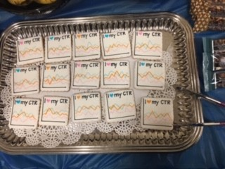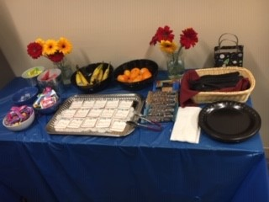 A spread of treats at Hennepin Healthcare NCRW



Nancy Hedstrom, Kim Saterbuk, Linda Vanstrom, VA

Medical Center NCRW 2019 Happy Hour!

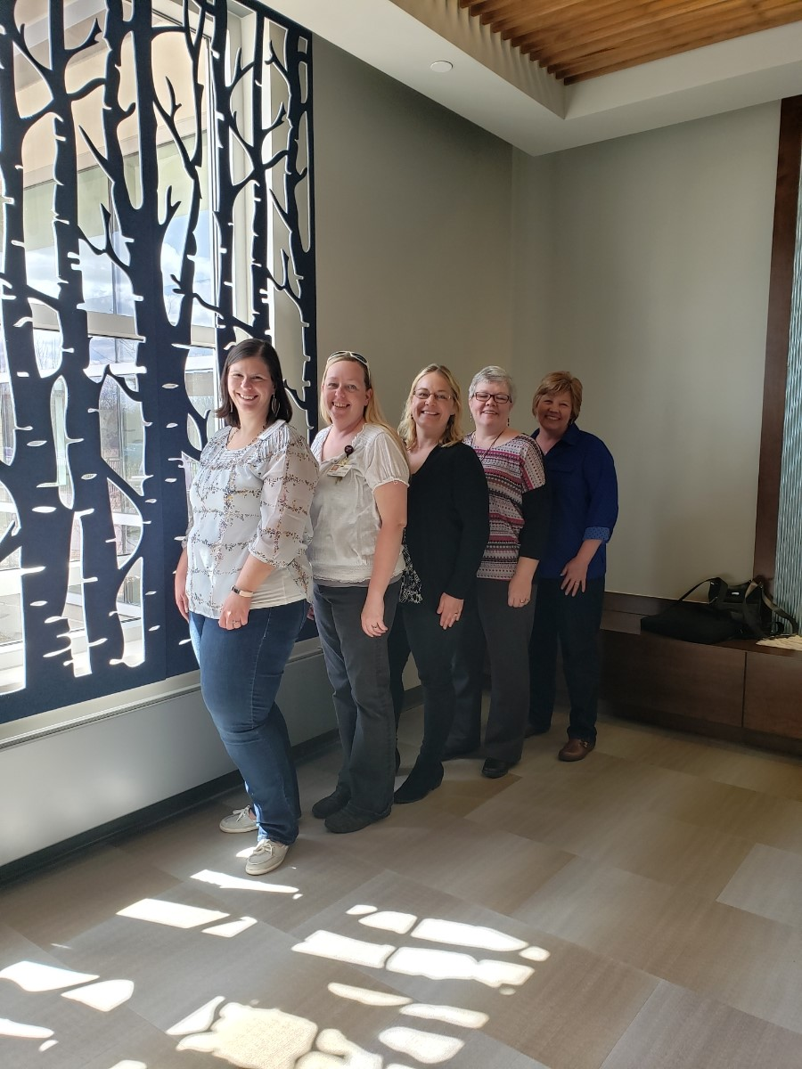**Installation of Officer 2019 and Spring Business Meeting**

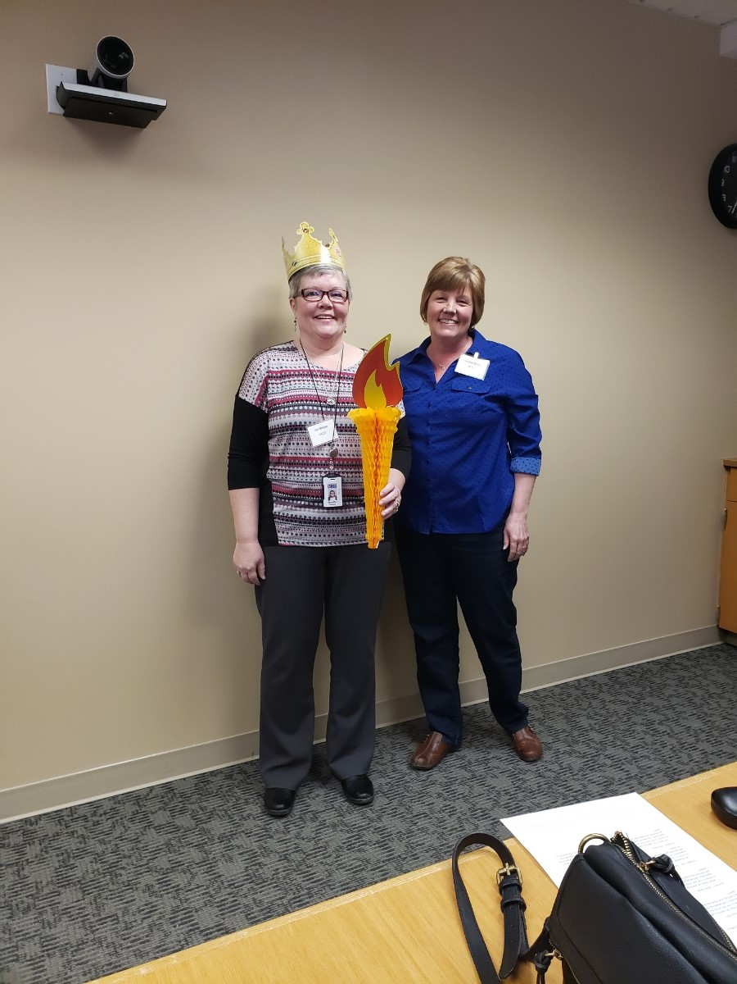

NCRA 2019 Denver CO

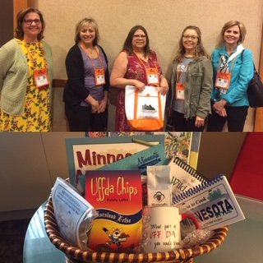 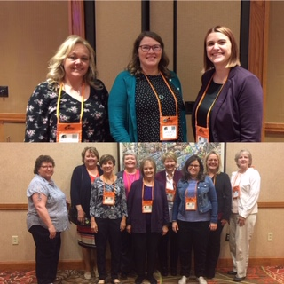

 Meet the 2019 MCRA Executive Committee

**Jen Nelson**, CTR, NR-EMT – *President:* MN Cancer Surveillance System, St. Paul. Member since 2011.

**Jess Klaphake**, RHIT, CTR – *President-Elect:* St. Cloud Hospital/Coborn Cancer Center, St. Cloud. Member since 2014.

**LeeAnn Olson**, CTR - *Past President:* MN Cancer Surveillance System, St. Paul. Member since 1996.

**Kathy Lougiu,** CTR – *Communications & MODMM:* Hennepin Healthcare. Member since 2014.

**Linda Vanstrom**, RHIT, CTR – *By-laws:* Minneapolis VA Health Care System, Minneapolis. Member since 1994.

**Amanda Hlad**, RHIA, CTR – *Treasurer:* St. Joseph’s Medical Center, Brainerd. Member since 2007.

**Jackie Halsey,** CTR– *Secretary:* Rochester Community & Technical College, Rochester. Member since 2010.

**Carol Forbes-Manske**, CTR – *MCSS Liaison:* MCSS, St. Paul. Member since 1986.

**Chunny Daiker**, BS, RHIT, CTR – *Membership:* Hennepin County Medical Center, Minneapolis. Member since 2009.

**Tom Coles**, CTR, CHES – *Website:* Allina-Abbott Northwestern Hospital, Minneapolis. Member since 2009.

**Janice Anastasi, Carol Forbes-Manske, Nancy Hedstrom, Erin Hammell** – *Nominating Committee*

**Carol Forbes Manske, LeeAnn Olson, Jane Siekkinen**– “Laurie Griffin *Outstanding Member” Award Committee*

**Candace Schoolmeesters**, **Heidi Leach, Jen Nelson**– *Professional Development*