MCRA/WCRA 4th Annual Regional Education Conference
Hosted  by | 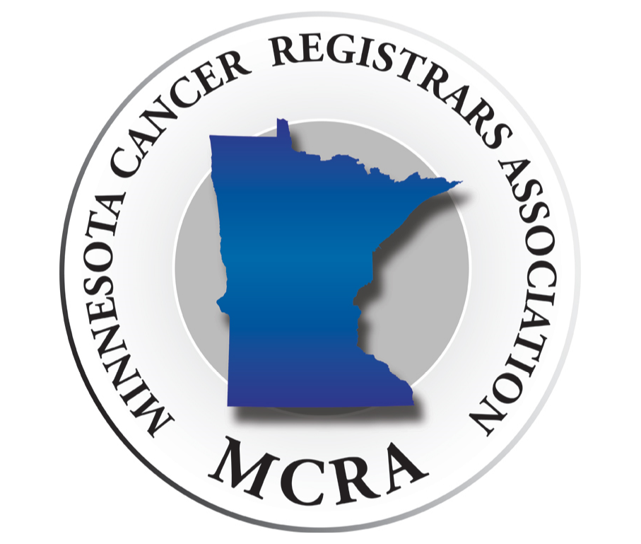 | &

September 12th – 13th 2019
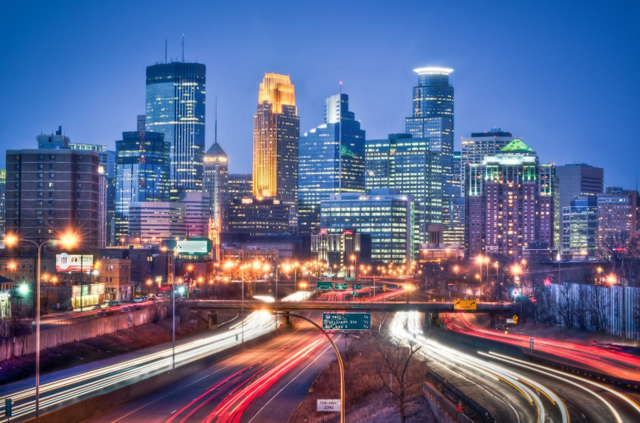 | Bloomington, MN | 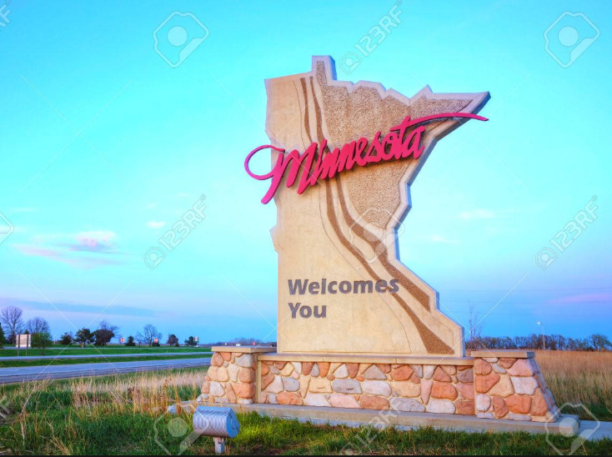

Embassy Suites Minneapolis Airport  7901 34th Ave S  Bloomington, MN | 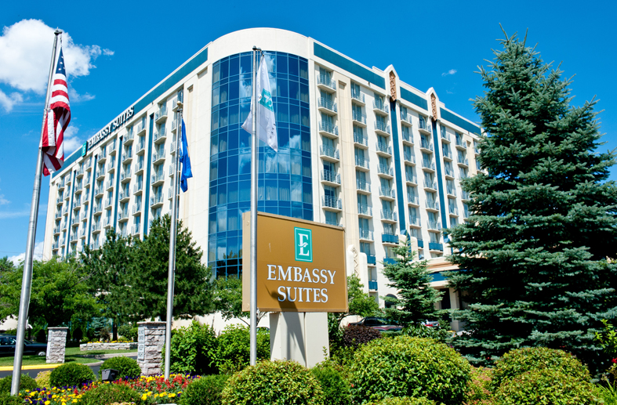

This event will qualify as a Regional Educational Activity for CoC Standard 1.11
NCRA credit is being applied for
Thursday, September 12
7:00am | Registration
7:55am | Welcome  Tamarack Ballroom
8:00am – 10:00am | Solid Tumor Rules  Louanne Currence, RHIT, CTR  Tamarack Ballroom
10:00am – 10:15 am | Morning Break & Vendor Exhibits  Cedar Ballroom
 | MCRA Track | WCRA Track
10:15am – 11:15am | Minnesota State Updates  Tamarack Ballroom | Wisconsin State Updates  Itasca Room
11:15am – 12:00pm | MCRA Business Meeting  Tamarack Ballroom | WCRA Business Meeting  Itasca Room
12:00pm – 1:00pm | Networking Lunch
1:00pm – 2:00pm | AJCC Chapter 1 Review  Louanne Currence, RHIT, CTR  Tamarack Ballroom
2:00pm – 2:15pm | Afternoon Break & Vendor Exhibits  Cedar Ballroom
2:15pm – 3:15pm | Pharynx  Louanne Currence, RHIT, CTR  Tamarack Ballroom
3:15pm – 4:15pm | Question Panel  Louanne Currence, RHIT, CTR  Tamarack Ballroom
4:30pm | Social Hour  Woolley’s North Area

Friday, September 13th
7:00am | Registration | Breakfast
7:55am | Welcome  Tamarack Ballroom
8:00am – 8:45am | Cancer Data: It Makes a Difference  Paula Lindgren, MS  Biostatistician, MN Department of Health  Tamarack Ballroom
8:45am – 9:45am | Hematopoietic  Louanne Currence, RHIT, CTR  Tamarack Ballroom
9:45am – 10:00am | Morning Break/Vendor Exhibits  Cedar Ballroom
10:00am – 11:30am | Melanoma  Louanne Currence, RHIT, CTR  Tamarack Ballroom

Conference Fees
Early Bird Rate (06/03/19 – 06/30/29)
 | Thursday & Friday
MCRA/WCRA Member | $125
Non-Member | $150
Student | $80

Regular Rate (07/01/19 – 08/23/19)
 | Thursday & Friday
MCRA/WCRA Member | $150
Non-Member | $175
Student | $80

Rate After 08/23/19
 | Thursday & Friday
MCRA/WCRA Member | $175
Non-Member | $200
Student | $100

*Students cannot be currently working in the registry field and must show proof of enrollment in a RHIT/RHIA or CTR program with their registration to be eligible for the student rate. Please provide a photocopy of your student ID with year or enrollment or an unofficial transcript on school letterhead.

*Cancellation Policy: Cancellations must be received in writing by 8/23/19 to be eligible for a refund. MCRA will accept cancellations by mail or e-mail and will provide a refund to those received on or before 8/23/19. For cancellations received during the specified time period, the refund will be issued on the next business day after the last day of the conference. MCRA will refund the registration fees paid, less a $50 processing charge. No cancellations will be accepted for refund after 08/23/19. Attendee substitution is permitted.

Registration
To register for the 4th Annual MCRA/WCRA Regional Conference follow this https://fs28.formsite.com/minnesotaMCRA/2019RegionalConference/index.html and complete the online registration. There are options to pay by check or through PayPal with an account or as a guest with a credit or debit card.

If paying by check please print out your registration confirmation and mail it with a check made out to MCRA to:
Amanda Hlad
6429 200th Street
Randall MN 56475

Group checks are welcome but we ask that individual attendees complete the online registration and then give their organization their printed registration confirmation to be mailed with the check.

Please contact Amanda Hlad with any questions:
minnesotaMCRA@gmail.com

Lodging
Embassy Suites Minneapolis Airport
7901 34th Ave S
Bloomington, MN
952-854-1000
www.embassymspairport.com

Rates:
Double or King $154.00/night
*Plus tax. Includes Wi-Fi and breakfast both mornings. Non-hotel guests can buy a full breakfast for $17.00.

*There will be a light breakfast of fruit, pastries, and coffee available during registration time and through the first break.

A block of rooms is being held until 09/04/2019.
Individuals will need to call to make a reservation and mention the MCRA/WCRA conference.

The hotel offers a complimentary shuttle to and from the Mall of America and the Minneapolis Airport. Blue line is up to attendees to purchase fare.

Local spots

>>Dining near Embassy Suites  Woolley’s Kitchen and Bar  AiRE Craft Grill  Martel’s Restaurant and Lounge  Blue Water Grill  Urbana Craeft Kitchen  D. Brian’s Deli  Hawaii Poke Bowl  Piada Italian Street Food  ZZQ Smokehouse  Hiko Sushi | >>Dining in Mall Of America  Benihana  Bubba Gump shrimp  Buffalo Wild Wings  Cadillac Ranch  Cantina Laredo  Chipotle  Chick-fil-A  Crave  Cowboy Jacks  Earth Burger  Dick’s Last Resort  Hard Rock Café  Melt Shop  Masu Sushi & Robata  Rainforest Café  TGI Friday’s  Food Court – fast food  Many more places listed

>>Attractions
Amazing Mirror Maze – 353 North Garden, Mall of America – Entrance fee $8.95Sea Life Centre Minnesota – 120 East Broadway, Mall of America – Purchase online $20.99
Nickelodean Universe – Mall of America – Invidual Ride Tickets purchased onsite
Fly Over America – Omni-theater type visual ride - $19.99
Moose Mountain Adventure Golf – Mall of America
Normandale Community College Japanese Garden – Free
Minnesota Valley National Wildlife Refuge (Long Meadow Lake)
Fort Snelling Cemetery
Northwest Airlines History Center – Crowne Plaza Aire MSP Airport
Long Meadow Lake Trail
Bloomington Hidden Garden
CMX Market Cinema – Mall of America
Sky Deck Sports Grille & Lanes – Mall of America

