2019 MCRA/WCRA Regional Conference
September 12th-13th

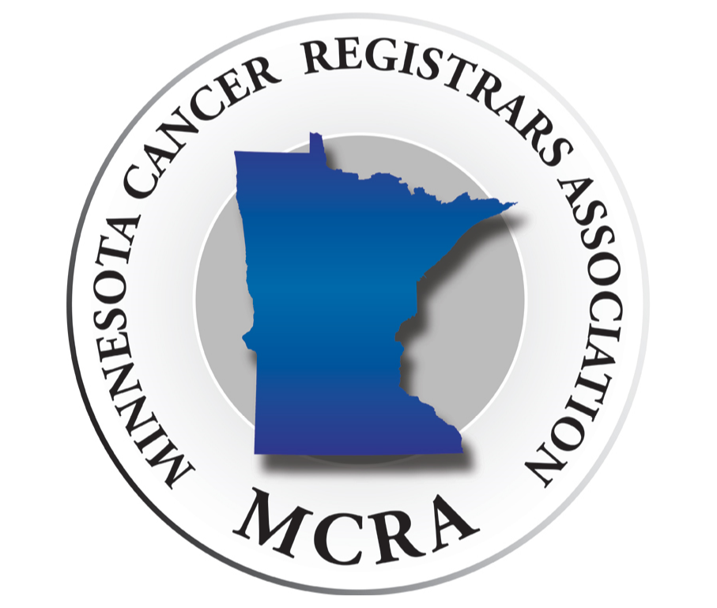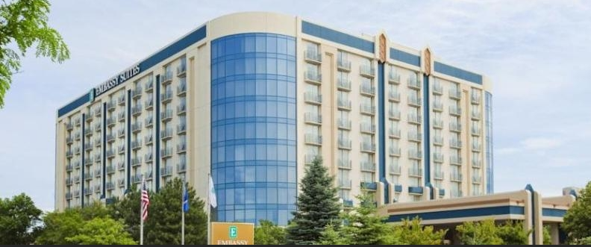

---------------------------------- Embassy Suites Minneapolis Airport ----------------------------------

Guest speaker Louann Currence, RHIT, CTR
- Presenting topics on both Thursday and Friday
- Full day Thursday and half day on Friday

Early Bird Registration Fees
- Member $125.00
- Non-Member $150.00
- Student $80.00
Conference brochure and registration coming soon!

