~ Save the Date ~
2019 Annual MCRA-WCRA Regional Conference
September 12th – 13th

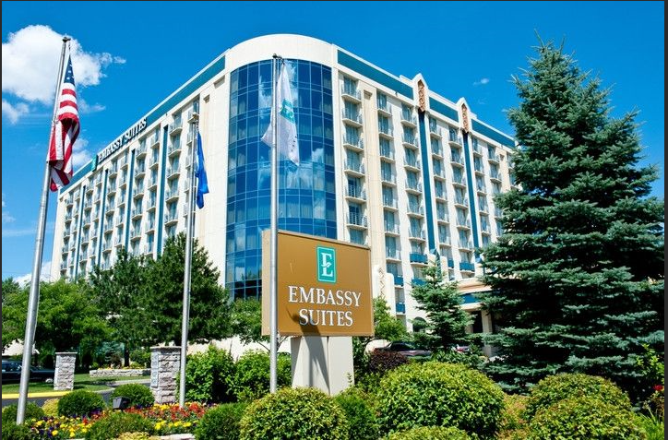

Embassy Suites Minneapolis Airport
7901 34th Ave S
Bloomington, MN

Hope to see you there!!

