Minnesota Cancer Registrars Association

THE MODMM

The Minnesota Oncology Data Managers Monitor

PRESIDENTS MESSAGE
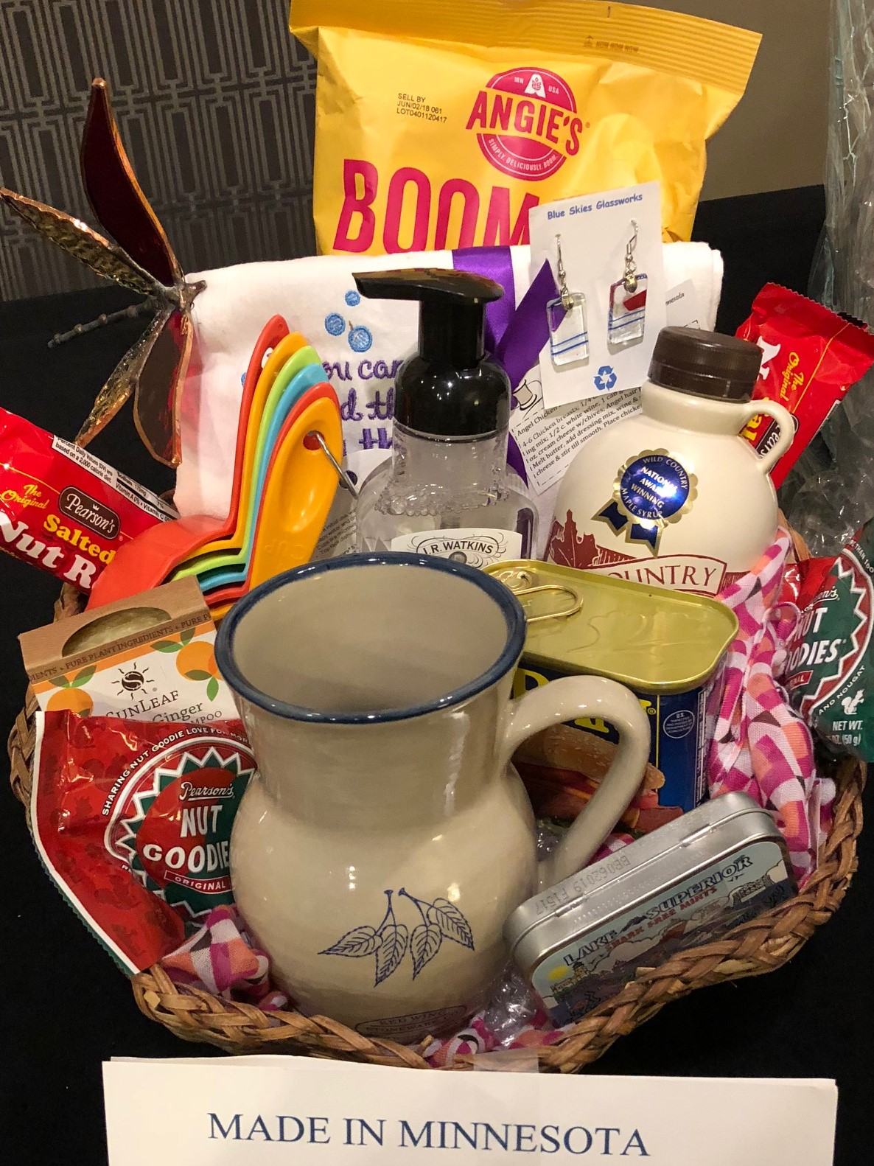
With the NCRA Workshop having been what seems like months ago, it is good to think back and reflect. What did I learn? What were the highlights? Is it worth the cost?

The Keynote Speaker, Dr. Vince Cataldo of Baton Rouge, LA started things out with a very interesting walk down memory lane of cancer. Did you know that the first documented form of occupational cancer was squamous cell carcinoma of the skin of the scrotum, recognized to be prevalent in young boys working as chimney sweeps? This resulted in the Chimney Sweepers Act of 1788, a child labor law, requiring a minimum age of eight for chimney sweeps. From there we went through the first cancer surgery, the first chemotherapy, Madam Curie, hormone treatment, development of screening methods, genetics, immunotherapy, vaccines and more, up to where we are today. This, to me, is what makes our jobs so interesting and rewarding. Screening methods and treatment options continue to evolve quickly and cancer registry plays a huge part in making this possible.

Following this was three days of an incredible amount of information on just about everything you need to know about cancer registry and cancer programs. Staging, staging, staging of course! Being as this was the first time I attended an NCRA Workshop while working for a central registry, I followed that tract on the third day. I was interested in ideas for developing quality assurance programs that work between the hospital registries and the central registries. The information provided by hospital registries to MCSS is vast and invaluable. I am hoping that we can develop better methods for communication especially regarding quality issues. This would be a great learning opportunity for us all.
The Highlights. Being amongst a large group of people whose work lives revolve around cancer registry. People who know what we do and understand the importance of what we do. This is always inspiring to me. Also, of course, hanging out with new and old friends from Minnesota. We had a wonderful time exploring New Orleans and sharing ideas.
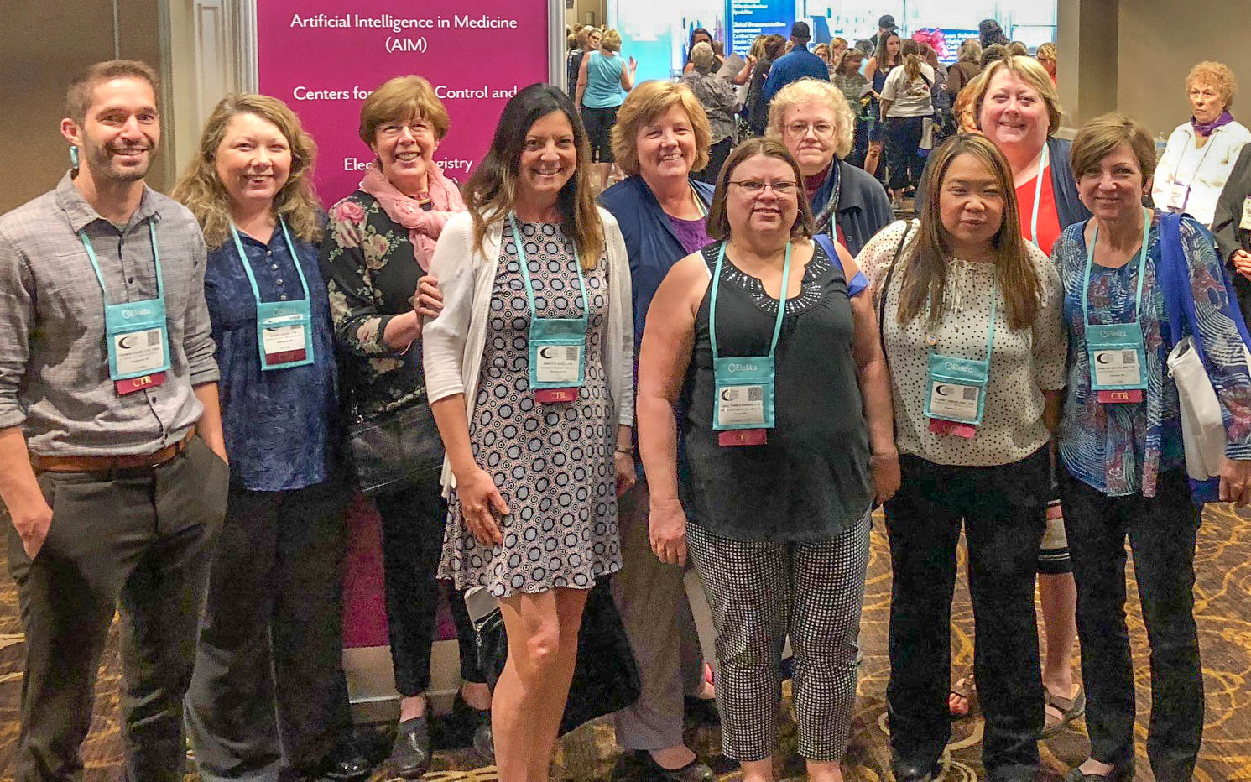
I attended the Presidents’ Luncheon where the leader asked each person to share what their association has accomplished recently and what the struggles are. Regional meetings, website development and volunteer involvement were the main issues. Here in Minnesota, we can be proud of the work that we are doing. We provide wonderful regional meetings with Wisconsin and we have a good website that provides members and visitors the information and access needed. We also have a great group of volunteers who work hard. That being said, there is always room for more! Remember that if you are the president of MCRA you are provided with a trip to the NCRA National Workshop!
Attending a national meeting is expensive. Every time I come back with a new appreciation for the work we are doing. New ideas, networking, and learning causes me to grow and become challenged. So thank you all for this opportunity!

Most sincerely,
LeeAnn Olson, CTR (MCRA President)

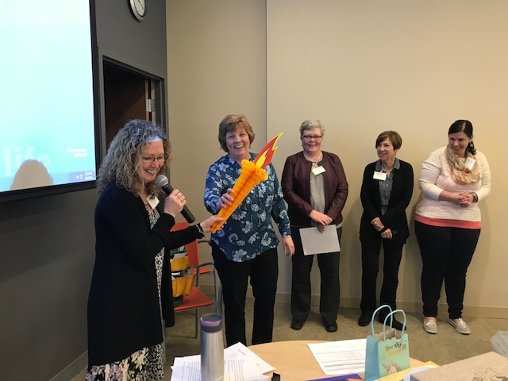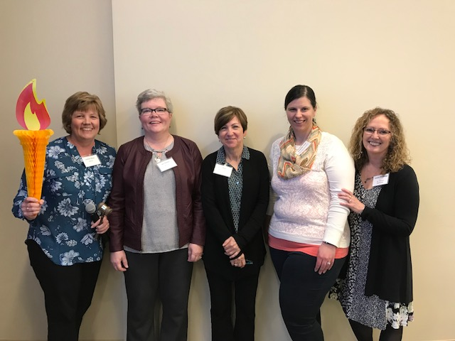

Nominating Committee
Submitted by Kim Gums

We would like to thank those who volunteered to remain in their current roles on the executive committee for another year along with the new volunteers for 2018.

At this time all roles are currently filled for 2018; however, we can always use additional volunteers to help on the executive board committees. In addition, we will be looking for volunteers in the fall to serve on the 2019 executive committee.

Thanks,
Kim, Carol, Nancy & Janice

MCRS REPORT
Carol Forbes-Manske

MCRS (MN Cancer Reporting System) staff are completing consolidation and abstracting tasks on 2016 reported cases. Facilities are asked to get their 2016 cases finalized and submitted to MCRS asap.
There is a committee at MDH working on obtaining remote access to electronic medical records from various facilities. This would save time for staff driving to and from facilities and staff are able to abstract and review more cases in the time that is saved driving. It also saves tax payers’ money with decreased costs of mileage, meals, parking, etc. Staff are very enthused about getting remote access.
MCRS’ CDC/NPCR on-site review in August.

Bylaws
Linda Vanstrom

Bylaws can be found on the MCRA website: click on the “Documents” tab, then the hyperlink for “MCRA Bylaws”.

We Are Professionals Who
Manage data describing the diagnosis and treatment of cancer. Promote quality cancer data collection and cancer program management.

TREASURERS REPORT
Amanda Hlad

The current balance in the MCRA bank account is $20,069.14. The income and expenses for the year to date currently results in a surplus of $3,800.00. The largest remaining expense for 2018 is the NAACCR webinars at $1,440.00.

*******************************************************

MCRA Cash Flow (1/01/2018 through 07/22/2018)
INFLOWS
2018 Membership Dues $5,073.83

2018 MCRA Spring Conference
Registration $1,931.08
Vendor $1,798.75
TOTAL 2018 Spring Workshop Registration $3,729.83
TOTAL INFLOWS $8, 803.66


OUTFLOWS
2018 Spring Workshop $2, 041.03
Membership
Gifts, Memorials $91.22
CTR Exam Stipend $100.00
NCRA Meeting
MCRA – President Elect Support $1,974.57
Miscellaneous $101.76
TOTAL NCRA Meeting $2,076.33
Website $183.60
Domain Account $59.70
Online Registration $249.95
TOTAL Website $693.25
TOTAL OUTFLOWS $5,001.83

OVERALL TOTAL $3,801.83

Website
Tom Coles

The website continues to be updated with NAACCR webinars as they are released for viewing. All of the 2018 webinars to date and most of the 2017 webinars are linked (and working!) to the MCRA webpage. Webinars from 2016 and earlier are not linked anymore. We have corrected most, if not all, of the issues that we were having earlier in the year. As of right now, the website seems to be pretty top notch!

The username is registry and the password is NeoMCRA18!

PROFESSIONAL DEVELOPMENT
Heidi Leach, Candace Schoolmeesters, Jen Nelson

The WCRA/MCRA Regional Conference agenda and registration link have been sent out and is also available on the website! Conference dates have been set for October 11th and 12th in Wausau, Wisconsin! Early bird registration is open until July 27th!

With all of the new changes in 2018 here is a list of Important resources needed for 2018 coding.
- AJCC 8TH Edition, 3rd printing
- STORE Manual-not released (Mid-August?)
- SEER Summary Staging 2018 Manual https://seer.cancer.gov/tools/ssm/
- 2018 Solid Tumor Manual https://seer.cancer.gov/tools/solidtumor/
- ICD-O-3 2018 Implementation Guidelines-Note: new codes may be manually entered, however the codes, descriptions and data validations will be released with the final upgrade. https://www.naaccr.org/implementation-guidelines/#ICDO3
- SEER Registrar Staging Assistant for EOD Extent of Disease 2018 Schema List V1.2. https://staging.seer.cancer.gov/eod_public/home/1.2/ This provides valid values, definitions, and notes for:
o EOD Primary Tumor
o EOD Lymph Nodes
o EOD Mets
o SEER Summary Staging 2018
o SSDI’s including grade
- Site Specific Data items SSDI/Grade https://apps.naaccr.org/ssdi/list/
o SSDI Manual
o Appendix A and B
o Grade Manual
o Schema List
- NAACCR Standards and Data Dictionary http://datadictionary.naaccr.org/
o NAACCR Record Layout
o Required Status Table
o Data Descriptor Table
o Data Dictionary-This can be used to reference the new treatment fields (Radiation and Surgery) until the STORE Manual is released
- Grade Coding Instructions and Tables https://www.naaccr.org/SSDI/Grade-Manual.pdf

Reminder: NAACCR webinars are available on the MCRA website approximately 1 week after the live presentation. Take some time to view past presentations.
Congratulations to Amanda Bohlsen and Jessica Yernatich on passing your CTR Exam. They were recognized at the Spring meeting at HCMC.
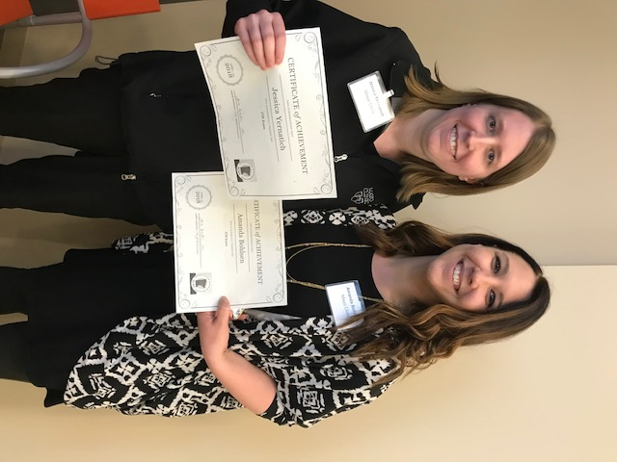

Next NCRA dates for the CTR Examination window is October 15 – November 3!
The 2018 Handbook/Application for Candidates and Exam Dates are coming soon! If you are looking for this information please contact ctrexam@ncra-usa.org to request a copy of the free handbook and dates.
For additional information, go to www.ctrexam.org

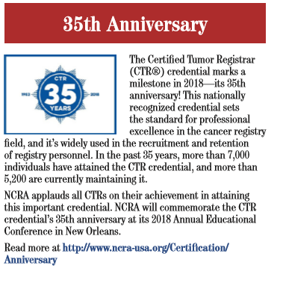

Communications
Jess Klaphake

There have been many resources released and soon to be released regarding all of the changes for 2018+ cases – check out the Professional Development section for a list of these resources and details.

There are a few documents pertinent to members on the MCRA Website – click on the “Documents” tab – here you can find MCRA Bylaws, the Policies and Procedures Manual and MCRA Job Descriptions.
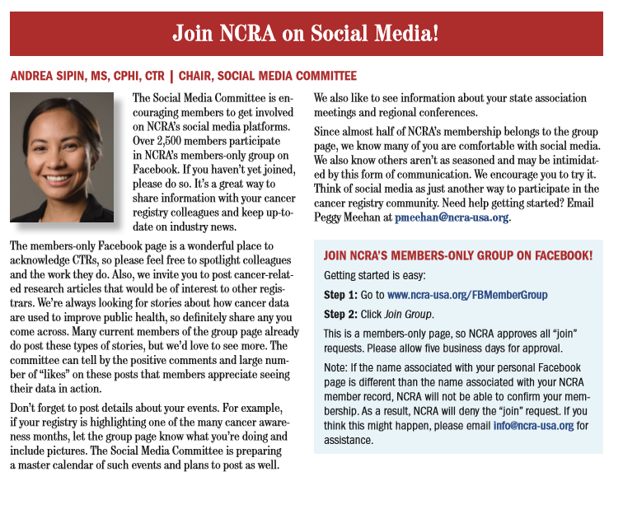

Membership
Chunny Daiker

2018 Membership Summary
Membership Numbers
- As of July 2018, there are 118 members.
  - 13 new members
  - 6 honorary members

Membership continues to be open year ‘round and members can join the association anytime!

NCRA Conference
Submitted by Linda Vanstrom
I attended the NCRA Annual Conference this year in New Orleans, a city whose motto is “laissez les bons temps rouler” which translates to “let the good times roll”. And roll they did in the evening, with me and many of the other Minnesota attendees sampling New Orleans specialties like po’boy sandwiches and beignets, listening to music at the House of Blues and taking a carriage ride through the French Quarter.
During the daytime, it was information that rolled and rolled and rolled. With all the new rules for 2018, the sessions covered many of those changes, including AJCC, Summary Stage and EOD with case demonstrations for each of six disease sites. A session titled “Coding Gremlins and LN Coding Clarifications”, highlighted common errors and described the correct ways to code lymph nodes. They also went over the new lymph node fields for breast and melanoma cases (Date Sentinel LN Bx, Sentinel LN’s Positive; Sentinel LN’s Examined and Date Regional LN Dissection). “Defensive Abstracting” confirmed the need to completely and accurately code text fields, which is especially important now as we try to find ways to document the new fields until they are available in abstracting software.
On the whole, a good overview of 2018 and the challenges we are facing.

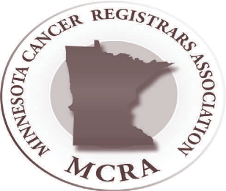
2018 SEER Workshop
Submitted by Carol Forbes-Manske

SSDIs – NAACCR website is the “official” site re: SSDIs, pdf manuals are on the NAACCR website. SEER*RSA has SSDIs listed also. “Grade” is considered an SSDI as it is site specific. The SSDI Manual has information regarding General Rules for Entering Lab Values & Other Measurements, General Definitions & Format of SSDI Codes, Schema Discriminators, SSDIs Required for Stage, SSDIs for specific sites.
Grade – Read the instructions for Solid Tumors in their entirety. There are now Letters and Numbers for grade coding. (Numeric pre-2018 grade codes have been changed to alpha codes for 2018+.) For example Breast, grades 1-3 are preferred for invasive cancer. L, M, & H are for in situ only. A-D are generic/historic grades such as well differentiated, moderately differentiated, etc. A-D are ONLY used if 1-3 or L, M, H are not documented. Grade “9” is used for heme/lymphoid except for one histology (follicular lymphomas) & one site (occular adnexal lymphoma). Blank is allowed for post-therapy grade.
Clinical grade cannot be blank. If one grade is given and it is unknown whether it is clinical or pathological, enter as clinical grade and code unknown (9) for pathological grade and leave post-therapy grade blank. (This would probably be used if patient diagnosed elsewhere and came to your facility for all or part of 1st course of treatment.)
Heme/Lymph Neoplasms – no longer coding grade EXCEPT:
- Ocular adnexa lymphoma, chapter 71
- Follicular lymphoma for 9690/3, 9691/3, 9695/3, 9698/3…
All other lymphomas would have clinical & pathological grade entered as “9” & post-therapy grade blank.
Questions from NAACCR Forum Shared:
Q1) How is grade coded with biopsy in 2017 & definitive surgery in 2018. Path report used 2018 CAP. A1) Code 2017 grade as patient diagnosed in 2017. Grade applies to year diagnosed, not year treated.
Q2) If no residual ca at time of definitive surgery, is pathological grade 9? A2) No – use grade the clinical grade.
Q3) Bladder TURP – most grades will be clinical grade for bladder cancers. If no resection, what grade do we assign? A3) Use “9” for pathological grade.
Radiation Oncology Coding – 24 new radiation data items for 2018, new “phase” specific (replaces modality & boost). There are rules defining when a phase begins. With 2018+ diagnoses & STORE, RT is documented in order of treatment given. If primary volume is LN, i.e. lymphoma “RT to Draining LNs” w/b 88. Code for 00 if diagnosed at autopsy. Code 08 – LN region, NOS, different code than primary - Code 09. Dose per fraction, Total dose (record what was actually delivered, not what’s planned), # of fractions (if patient had treatment in morning & again in the afternoon, that is 2 fractions, not 1). Questions/Answers –
Q1) Phase I applicable if RT to a mets? A1) Yes. If both primary & mets treated, record in separate phases (with primary entered in phase I). If only mets site, record in phase I.
Q2) Will total dose be auto-calculated? A2) Probably not, if you have 4 phases, you will need to add the dose from phase 4 even though it is not documented in RT (only 3 phases are recorded).
Q3) If you have RT to multiple metastatic sites with varied modalities & treatment volume, and possibly different end dates, how do you record this? A3) Record 3 phases in Phase I, II, & III & if you have 6 sites, record all radiation information in text.
Solid Tumor Rules – Continue to use previous MPH rules for sites not updated for 2018.
Revisions/Changes:
- Standardized similar rules throughout except for CNS, breast, skin & other
- Each revised site group now has specific priorities for coding
- Timing rules clarified, especially for urinary sites
- Timing rules differ by each site
  - One year or less = 365 days or less
  - More than 1 year = 366 days or more
    - Do NOT factor in if patient went on vacation, hunting, waited for treatment until crops planted/harvested
- Timing definitions of clinically disease-free
  - Snowbird, have date of diagnosis but unsure if clinically disease-free, default to date of diagnosis
Coding Histology 2018+
Priority –
- Updated ICD-O Histologies & Terms Table https://seer.cancer.gov/icd-o-3
- 2018 Solid Tumor Rules
- ICD-O
How to Use Histo Rules –
- Do not use to determine reportability
- Single or Multiple tumor
  - H rules
  - Code histology prior to neoadjuvant therapy
  - List of terms/modifiers not used
- Do not use subtypes/variants described by ambiguous terms
- Priority order for source documents for each site listed (biomarkers included now)
CAP Protocols are not listed 1st as they provide guidelines. It is a check list.
Most Important Rule – STOP at first rule that applies.
Rules were written to cover 85-90% of cases. For outlying cases/issues, ask your pathologist first. You can submit questions to SINQ (include year of diagnosis).
(FYI – WHO is re-using old/obsolete histology codes for new histologies. Running out of numbers to use for new histologies.)
Collision tumors are counted as two individual tumors for determining multiple primaries. DO NOT CODE ONE PRIMARY WITH MIXED HISTOLOGY.
Q & A:
Q1) New anastomotic site – polyp adenoca dxd in 2017 & now recurrence in anastomotic site in 2018 – what should be coded? A1) Code to polyp in 2017. There would be a new primary for 2018, adenoca in a polyp would be coded to adenoca in 2018, not to polyp.
Q2) Clinically disease-free date starts at time of diagnosis or time clinically disease-free? A1) Diagnosis date. Epidemiologists studies also use date of diagnosis.

2018 NCRA Conference – New Orleans, LA

Jane Siekkinen, Manager, Oncology Registry
Park Nicollet – Frauenshuh Cancer Center – Methodist Hospital

The opportunity to attend the National Cancer Registrars Annual Conference is always a privilege. The networking opportunity to talk with colleagues, speak with vendors, and hear educational sessions on our profession is so helpful. I encourage you to go if you have never been. Below are my notes from three of the talks given on the first day of the conference.

The keynote speaker this year was Dr. Vince Cataldo from Baton Rouge, LA. Dr. Cataldo spoke on “A Biography on Cancer: Where we have been and where we are going”. Some interesting bullets from his talk:
- Did you know that Dr. Sidney Farber, (namesake of the Dana Farber Cancer Institute), was the father of modern chemotherapy? He demonstrated the effects of the first chemotherapy on children with leukemia.
- There is currently a hospital in Houston, TX, experimenting with the use of robotics. The surgeon is operating remotely from one hospital, while the patient is in an operating room at a different hospital. Mind boggling…
- Lung cancer is the #1 killer in both men and women (154K) vs. 41K deaths due to breast cancer. The life expectancy of a patient with metastatic lung cancer is 10.5 months.
- Lung cancer screening trial update: One life saved out of 320 screenings. A $52,000 cost per life year gained.
The Chief for the Cancer Surveillance Branch of the CDC gave a talk on how they use registry data for prevention and control. Dr. Vicki Benard compared the rules changes we are going through to a Tsunami and emphasized these changes are necessary in order for us to be relevant. Go to www.cdc.gov/cancer/public-use for access to U.S. Cancer Statistics Public Use Databases. It is user friendly cancer data on state vs. national statistics. Tobacco cessation is still the leading preventable cause of cancer. There are 13 cancers related to obesity. She discussed the “complete streets” in Indiana – more bike lanes and walking.

Dr. David Winchester, Medical Director of Cancer Programs, American Colleges of Surgeons, gave an update on the CoC and NCDB. The main takeaways for me were:
- Quality improvement measures are high priority. There are 23 measures currently and 20 more measures “in the hopper”.
- The first NAPRC (rectal accreditation) was conducted one month ago.
- Highlights were shown on improvements in measures from baseline to now.
- Discussed the upcoming COMET Study (webinar now July 12th).
I hope you all have a wonderful summer! Keep smiling and collecting that data! Our work is important and relevant!!

Meet the 2018 MCRA Executive Committee

LeeAnn Olson, CTR - President: MN Cancer Surveillance System, St. Paul. Member since 1996.

Jen Nelson, CTR, NR-EMT – President Elect: MN Cancer Surveillance System, St. Paul. Member since 2011.

Linda Vanstrom, RHIT, CTR – By-laws: Minneapolis VA Health Care System, Minneapolis. Member since 1994.

Amanda Hlad, RHIA, CTR – Treasurer: St. Joseph’s Medical Center, Brainerd. Member since 2007.

Chris Bushaw, Med, RHIT, CTR – Secretary: Rochester Community & Technical College, Rochester. Member since 2016.

Jess Klaphake, RHIT, CTR – Communications & MODMM: St. Cloud Hospital/Coborn Cancer Center, St. Cloud. Member since 2014.

Carol Forbes-Manske, CTR – MCSS Liaison: MCSS, St. Paul. Member since 1986.

Chunny Daiker, BS, RHIT, CTR – Membership: Hennepin County Medical Center, Minneapolis. Member since 2009.

Tom Coles, CTR, CHES – Website: Allina-Abbott Northwestern Hospital, Minneapolis. Member since 2009.

Janice Anastasi, Kimberly Gums, Carol Forbes-Manske, Nancy Hedstrom – Nominating Committee

Jackie Halsey, LeeAnn Olson, Cindy Sanborn – “Laurie Griffin Outstanding Member” Award Committee

Candace Schoolmeesters, Heidi Leach, Jen Nelson – Professional Development

